Submarine Cable Analysis for US Marine Renewable Energy Development

Benjamin D. Best 1

Levi F. Kilcher 2

2017-07-26  
1: EcoQuants, Santa Barbara, CA  
2: National Renewable Energy Lab, Golden, CO

Table of Contents

Executive Summary 2

Background 3

Methods 4

Study Area, Submarine Cables, Depth and Energy Data 4

Submarine Cable Avoidance Zones 6

Depth-Varying Cable Buffer 6

Results 7

Cable Buffer 7

Overlap of Cable Buffer with Renewable Energy 9

Tidal 12

Wave 14

Wind 16

Conclusions 17

(APPENDIX) Appendix 18

Detailed Maps by US Territory of Cable Buffer and Renewable Energy 18

Alaska 18

Tidal 18

Wave 19

East 20

Tidal 21

Wave 22

Wind 23

Guam 24

Gulf of Mexico 25

Tidal 26

Wave 27

Wind 28

Hawaii 29

Wave 30

Wind 31

Johnston Atoll 32

N Mariana Islands 33

Palmyra Atoll 34

Puerto Rico 35

Tidal 36

Wave 37

US Virgin Islands 38

Tidal 39

Wave 40

Wake Island 41

West 42

Tidal 43

Wave 44

Wind 45

References 46

# Executive Summary

Marine energy (OSW, tidal, wave) is a promising area for the U.S. energy mix… Recent OSW deployment in Roald Island…

Marine spatial planning is important as a diverse and growing range of industries begin utilizing the ocean… A first step is that each sector understand the existing landscape and opportunities for the others… This report investigates the overlap between existing submarine cables and the U.S. marine energy resource…

Operation and maintenance of submarine cables may conflict with marine renewable energy development. Although submarine cable locations are publicly accessible, safe setback distances are not readily available for planning new marine renewable energy development.

We applied industry-advised safety buffers that varied with depth to existing submarine cables for "minimum" (2*depth, i.e. "2z") and "recommended" (3*depth, i.e. "3z") horizontal distances, both having a minimum 500 m buffer. The cable buffer area ranged from 29.35% (242,042 km2 [3z] of 824,679 km2 total) in the West Coast region owing to many cables present and the steep continental shelf, to virtually nill 0.01% (42 km2 [2z] of 406,970 km2 total) in Wake Island (Table 2).

Overlap of cable buffers with marine renewable energy was assessed for tidal, wave and offshore wind energy based on estimates from the National Renewable Energy Lab (NREL). Generally the highest proportion of energy is in the lower classes least likely for development where the highest area of overlap with cable buffers also exist (Figure 3; Table 3).

The highest wind speed classes (10-11 & 11-12 m/s) are however also occupied by the highest percentage of cable buffer overlap (55.7% & 39.8% for 3z, 39.8% & 15.9% for 2z respectively). These uncommon high wind speed areas are limited to Hawaii and West territories (Table 6; Figure 6, 21 and 35). …

Wave energy has a bimodal distribution, most abundant in the lowest class (997,570 km2 for 0-10 kW/m) with a sharp drop at the next lowest class (292,692 km2 for 0-10 kW/m) and then ramping up to roughly half the highest class (532,533 km2 for >30 kW/m). Overlap with cable buffers for the highest two classes (20-30 & >30 kW/m) is just over 5% (5.2% & 5% for 2z, 6.8% & 6.7% for 3z). Similar to wind, these high energy wave classes are limited to the Pacific territories of Hawaii, West and Alaska (wind for Alaska was not available) (Table 5; Figure 5 for bargraph; Figure 20 for Hawaii wave map; Figure 34 for West wave map; Figure 9 for Alaska wave map).

The cable overlap for tidal energy sites is 20.1% (12 of 59 km2) for low-intensity sites (500-1,000 W/m2) and less than 3% for the the most energetic sites with power densities >1,000 W/m2.

In summary, …

# Background

Demand for abundant and diverse resources in the oceans is growing, which is emphasizing the importance of marine spatial planning. To inform development of Marine Hydrokinetic (MHK) and Offshore Wind (OSW) resources, the Department of Energy (DOE), NREL, and EcoQuants, LLC have undertaken this competing uses analysis between MHK/OSW technologies and subsea power/telecom cables. The first step in this work is to identify and quantify the overlap between the MHK/OSW resource availability and existing cable routes.

The analysis is done in terms of resource area because the task of quantifying actual impacts on available resource is a non-trivial undertaking that involves subjective decisions of identifying resource opportunities. Quantifying overlap in-terms of resource area—on the other hand—is significantly more straight forward, and useful to marine spatial planners.

Several publicly available data layers are available that identify cable routes (e.g. MarineCadastre.gov currently hosts an offshore cables geographical information system (GIS) data layer) and MHK/OSW resource density (MHK Atlas, Wind Prospector). The cable route linear features, however, do not indicate the setback distance necessary to accommodate subsea cable maintenance requirements. Industry reports (Communications Security, Reliability and Interoperability Council IV 2014, 2016) from the International Cable Protection Committee (ICPC) of the North American Submarine Cable Association (NASCA)[1] advise on setback distances that inform this analysis.

# Methods

## Study Area, Submarine Cables, Depth and Energy Data

The study area consists of the US waters (Flanders Marine Institute 2016), i.e. the 200 nm extent deemed the exclusive economic zone (EEZ). We used the offshore cable dataset "NOAA Charted Submarine cables in the United States as of December 2012" available through MarineCadastre.gov.[2] The territory of the contiguous US was divided into regions: Alaska, Hawaii, West Coast, East Coast, and Gulf of Mexico (VLIZ 2017). To accomodate territories overlapping the international dateline (Hawaii and Alaska), all input and output products were shifted from [-180,180] to [0,360]. For more details on the 12 territories used in this analysis, see Table 1 and Figure 1.

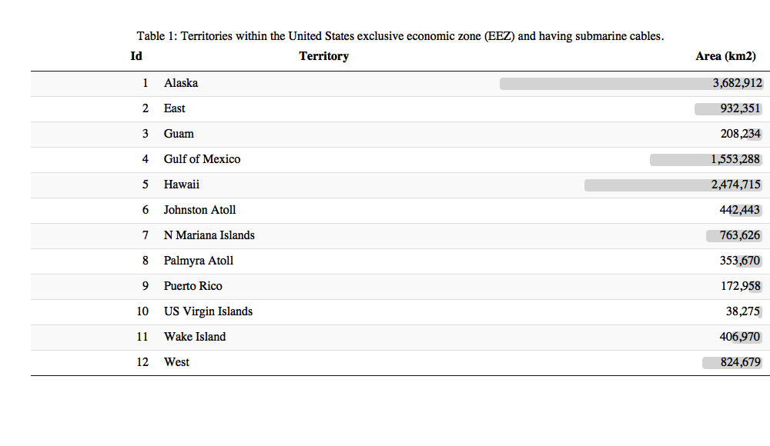

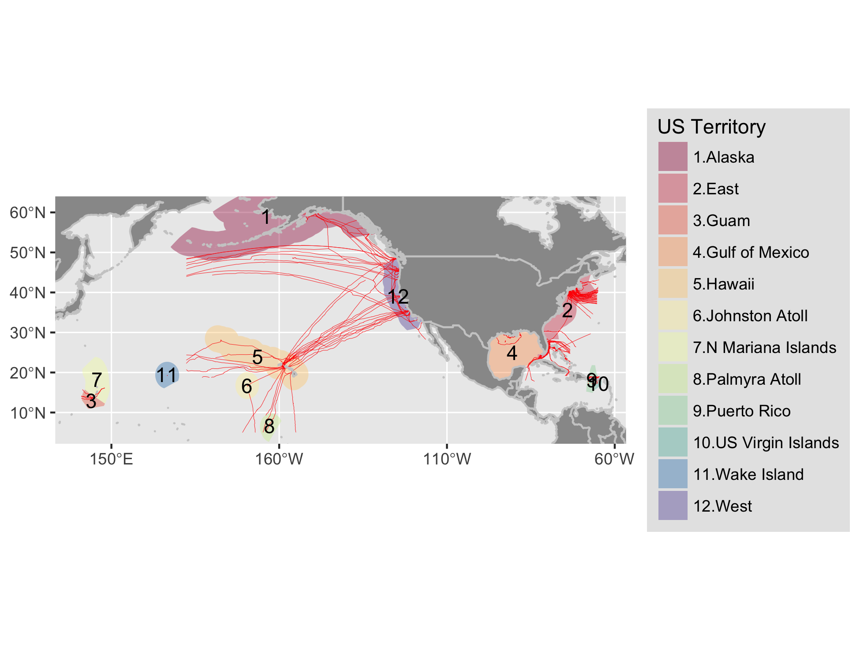

Figure 1 Map of NOAA Charted Submarine cables as of December 2012 within the exclusive economic zone (EEZ; 200 nm) of United States territories.

Bathymetric depth comes from the [GEBCO 30 arc-second grid](http://www.gebco.net/data_and_products/gridded_bathymetry_data/gebco_30_second_grid/)[3].

The marine renewable energy datasets are from NREL and accessible online via NREL's Wind Prospector[4] and MHK Atlas[5]. Tidal data were modeled using the Regional Ocean Modeling System and calibrated with available measurements of tidal current speed and water level surface in terms of watts per square meter (W/m2) (Haas et al. 2011). Wave data is based on a 51-month Wavewatch III hindcast database developed by the National Oceanographic and Atmospheric Administration’s (NOAA’s) National Centers for Environmental Prediction for estimation of wave power density in terms of kilowatts per meter (kW/m) (P. T. Jacobson et al. 2011). Wind data is for average offshore wind speed in meters per second (m/s) at a 90 m hub height.[6]

## Submarine Cable Avoidance Zones

The International Cable Protection Committee (ICPC) of the North American Submarine Cable Association (NASCA) outlined recommendations for siting new offshore renewable wind energy facilities and routing new cables. For new facilities they recommend a minimum of 500 m and further offshore twice the depth to the seafloor, per ICPC Recommendation 13 No. 2 (Communications Security, Reliability and Interoperability Council IV 2014). So for depths <= 250 m, a 500 m buffer from the cables applies and for depths > 250 m, 2 * depth is to be used. For placing new submarine cables, seperation distances are specified for minimum (2 * depth) and recommended (3 * depth), per related to ICPC Recommendation 2 No. 10 (Communications Security, Reliability and Interoperability Council IV 2014). We combined these two criteria into 2 sets of buffer distances for minimum ("2z": 2 * depth) and recommended ("3z": 3 * depth) avoidance zones, both with a minimum 500 m width.

## Depth-Varying Cable Buffer

A depth-varying buffer for "minimum" (2z) and "recommended" (3z) was calculated by intersecting depth with cables and buffering the cable by depth. Depth from the GEBCO grid was reclassed into 100 m increments starting with 250 m to apply a 500 m minimum for the 2z and 3z products, and converted to polygons for intersecting with the cable linear features. A custom Albers Equal Area Conic projection based on 1/6th the extent[7] of each territory was individually applied to minimize spatial distortion when buffering.

# Results

All analytical code to generate outputs, including this data driven report, are available in a publicly accessible online repository: <http://github.com/ecoquants/nrel-cables>. Here are particularly noteworthy files:

* data/
  + [lns_d1x.geojson](https://github.com/ecoquants/nrel-cables/blob/master/data/lns_d1x.geojson): lines of submarine cables segmented at 100 m increments with depth value for buffering, ie minimum 500 m and depth (z) for multiplying by 2 (2z) or 3 (3z).
  + [buf_2xdepth_incr100m.geojson](https://github.com/ecoquants/nrel-cables/blob/master/data/buf_2xdepth_incr100m.geojson): polygons for "minimum" avoidance zone for buffer at twice the depth (2z), mimimum 500 m.
  + [buf_3xdepth_incr100m.geojson](https://github.com/ecoquants/nrel-cables/blob/master/data/buf_3xdepth_incr100m.geojson): polygons for "recommended" avoidance zone for buffer at three times the depth (3z), mimimum 500 m.
* docs/
  + [packages_vars.R](https://github.com/ecoquants/nrel-cables/blob/master/docs/packages_vars.R): R code with variables and packages used across analysis (create_cable-buffer.R, extract_cable-energy.R) and reporting (report.Rmd)
  + [create_cable-buffer.R](https://github.com/ecoquants/nrel-cables/blob/master/docs/create_cable-buffer.R): R code to generate cable buffers at 100 m depth increments.
  + [extract_cable-energy.R](https://github.com/ecoquants/nrel-cables/blob/master/docs/extract_cable-energy.R): R code to extract renewable energy for cabled territories.
  + [report.Rmd](https://github.com/ecoquants/nrel-cables/blob/master/docs/report.Rmd): R markdown document for reproducible, data-driven generation of various report output file formats (report.pdf, report.docx, report.html)

## Cable Buffer

Of the original 230,835 km in the cable dataset (Figure 1), 97,321 km fell within the 200 nm of the US exclusive economic zone (EEZ), which was analyzed across 12 territories that overlapped with the cables (Figure 2). The cable buffer area ranged from 29.35% (242,042 km2 [3z] of 824,679 km2 total) in the West Coast region owing to many cables present and the steep continental shelf, to virtually nill 0.01% (42 km2 [2z] of 406,970 km2 total) in Wake Island (Table 2).

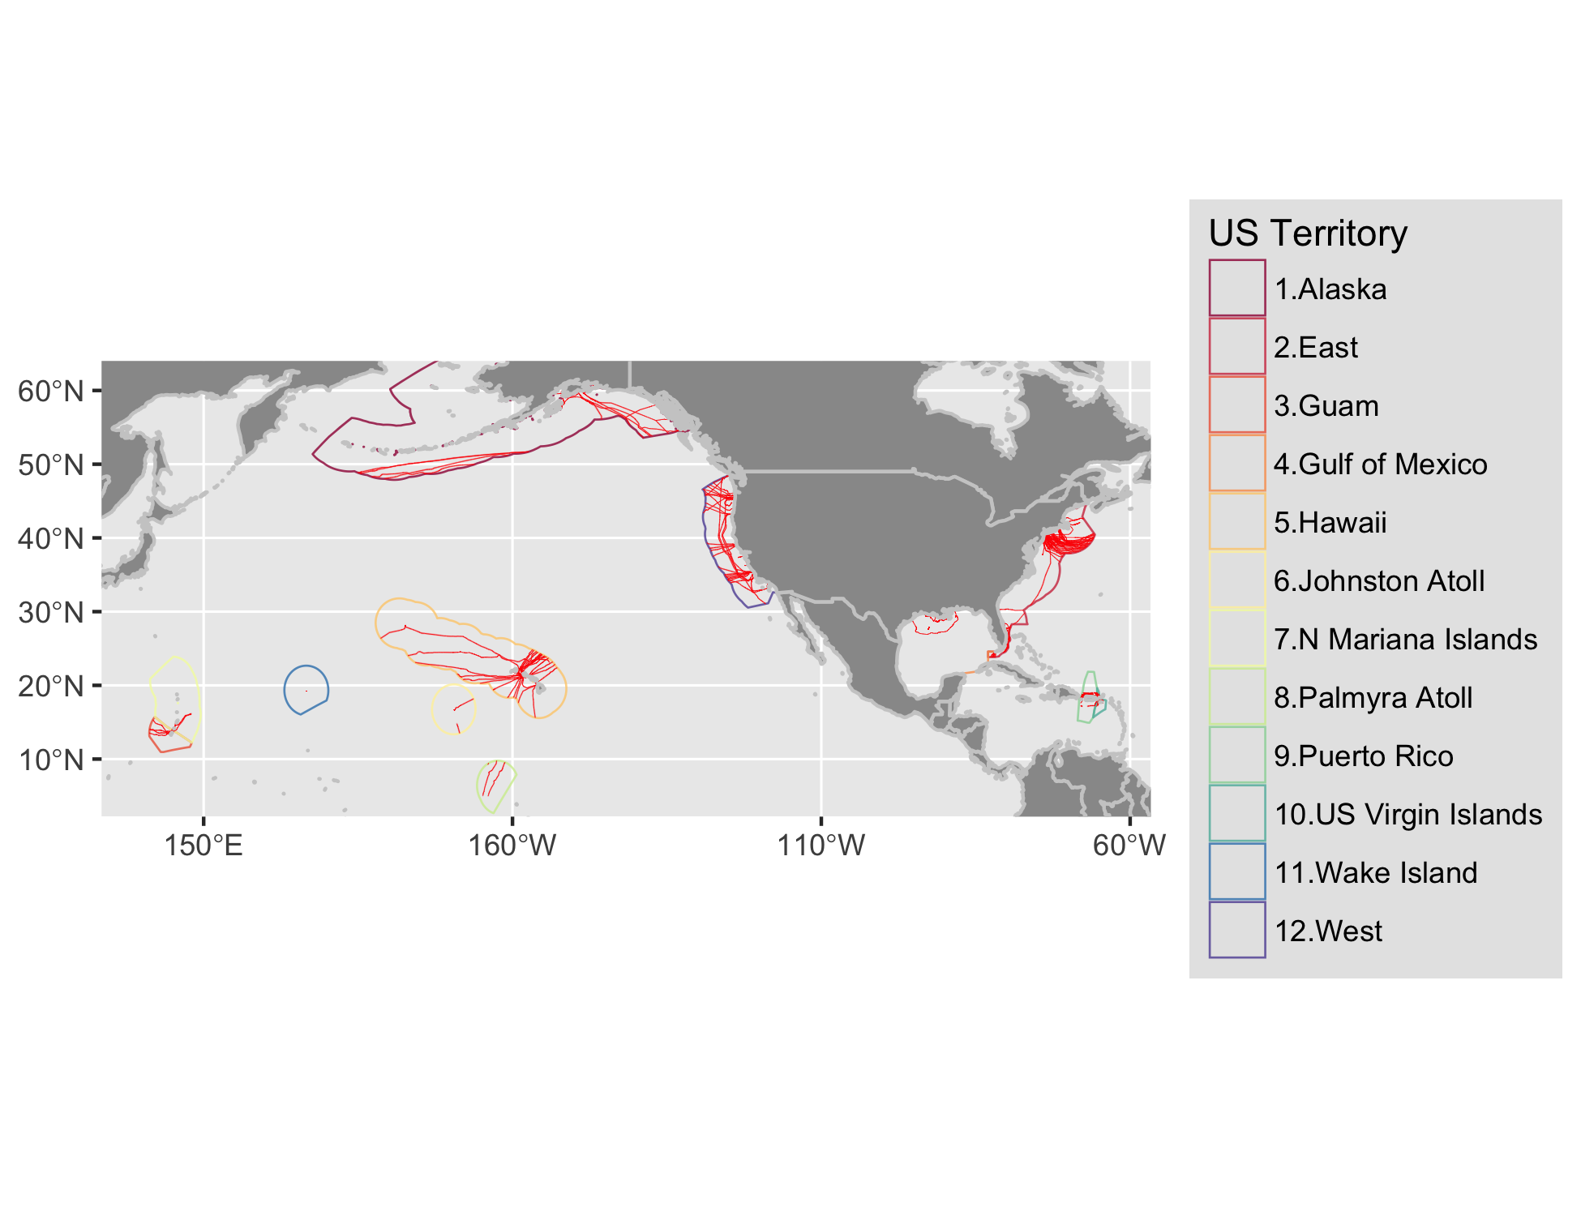

Figure 2 Map of submarine cable buffers within the exclusive economic zone (EEZ; 200 nm) of United States territories. In order to see the area covered by the buffers, please visit the Detailed Maps section.

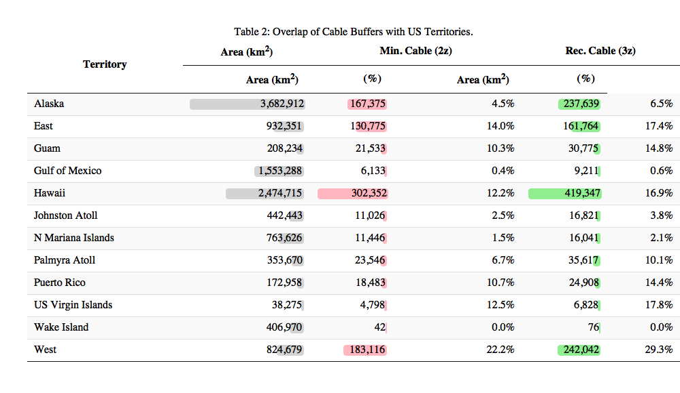

## Overlap of Cable Buffer with Renewable Energy

Generally the highest proportion of energy is in the lower classes least likely for development where the highest area of overlap with cable buffers also exist (Figure 3; Table 3). The highest wind speed classes (10-11 & 11-12 m/s) are however also occupied by the highest percentage of cable buffer overlap (55.7% & 39.8% for 3z, 39.8% & 15.9% for 2z respectively). These uncommon high wind speed areas are limited to Hawaii and West territories (Table 6; Figure 6 for bargraph; Figure 21 for Hawaii wind map; Figure 35 for West wind map). Overall wave energy has a bimodal distribution, most abundant in the lowest class (997,570 km2 for 0-10 kW/m) with a sharp drop at the next lowest class (292,692 km2 for 0-10 kW/m) and then ramping up to roughly half the highest class (532,533 km2 for >30 kW/m). Overlap with cable buffers for the highest two classes (20-30 & >30 kW/m) is just over 5% (5.2% & 5% for 2z, 6.8% & 6.7% for 3z). Similar to wind, these high energy wave classes are limited to the Pacific territories of Hawaii, West and Alaska (wind for Alaska was not available) (Table 5; Figure 5 for bargraph; Figure 20 for Hawaii wave map; Figure 34 for West wave map; Figure 9 for Alaska wave map). Tidal power is extremely dominated by the lowest energy class of 0-500 W/m2 covering 403,781 km2, which is 99.6% of the total area assessed. The cable overlap for the rare higher energy areas is at most 20.1% (12 of 59 km2) for 500-1,000 W/m2 in the West and less than 3% for the even rarer higher energy classes of 1,000-1,500 or >1,500 found only in Alaska or the East.

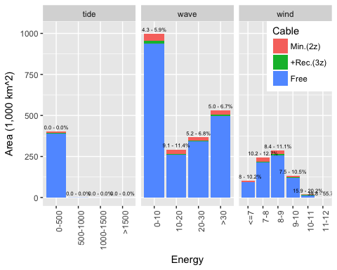

Figure 3 Energy by area and power class per US territory with cable overlay (minimum - recommended %).

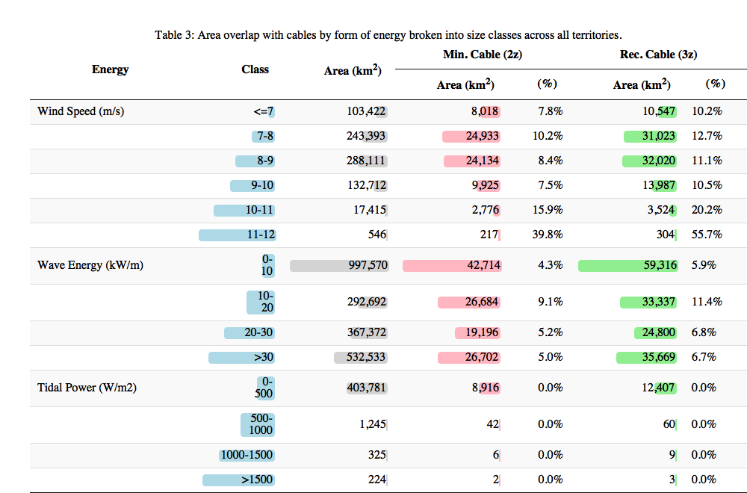

### Tidal

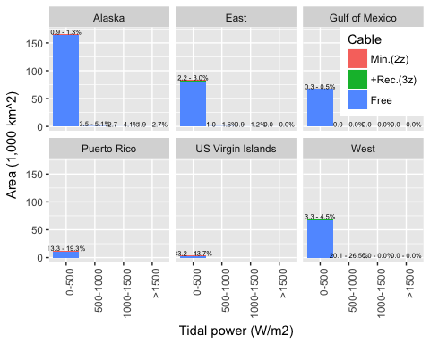

Figure 4 Tidal power (W/m2) and area per US territory with cable overlay (minimum - recommended %).

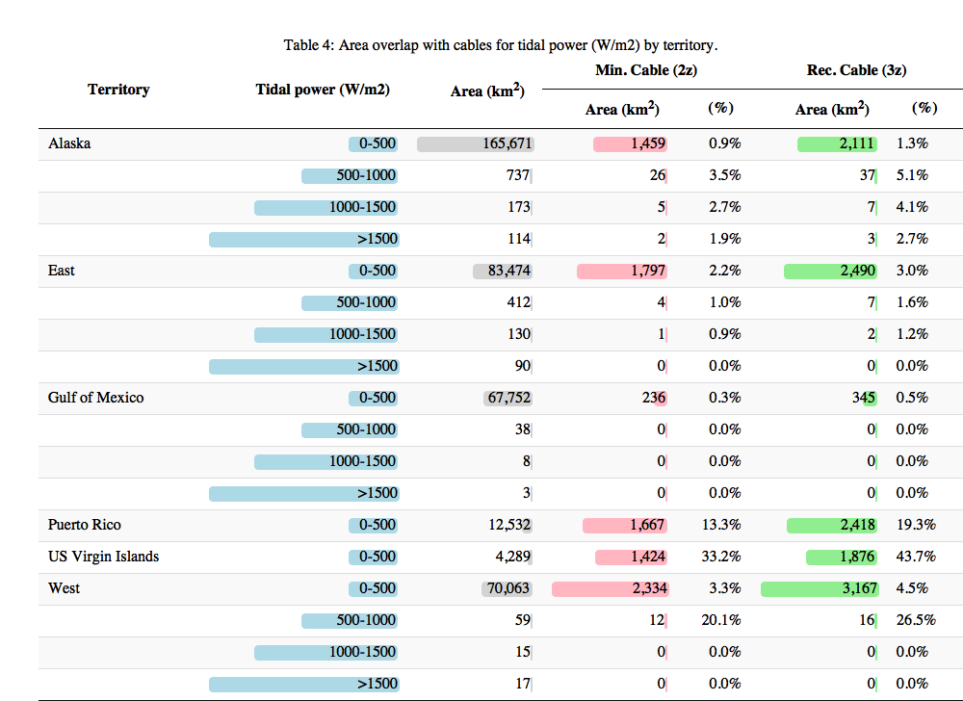

### Wave

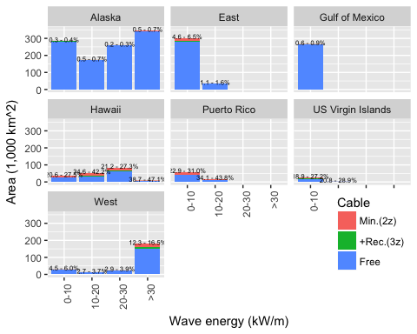

Figure 5 Wave energy (kW/m) and area per US territory with cable overlay (minimum - recommended %).

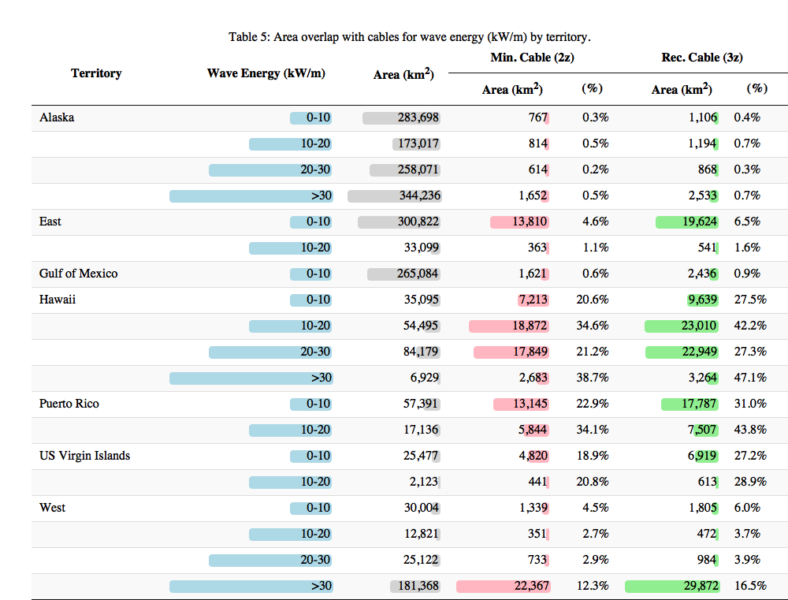

### Wind

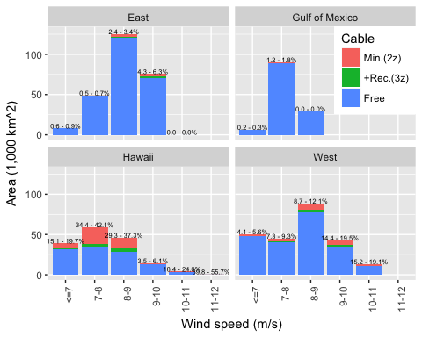

Figure 6 Wind speed (m/s) at 90m hub height and area per US territory with cable overlay (minimum - recommended %).

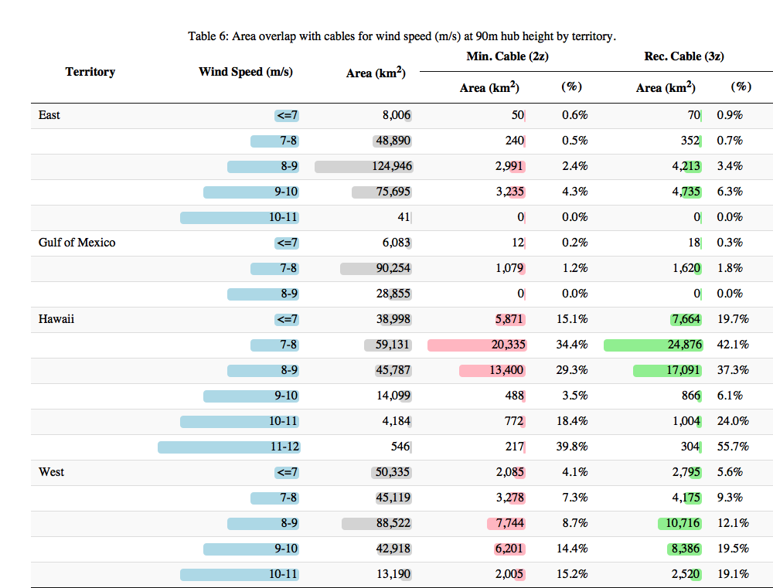

# Conclusions

Given climate change impacts of fossil fuel energy production (Pachauri et al. 2015), development of clean renewable energy alternatives are imperative for the sustainable future of the United States and rest of the planet. These energy sources however vary widely in geographic and temporal availability and may compete with other uses. The submarine cable industry provides critical power and telecommunication services, such that safe operation and maintenance must be heeded as marine renewable energy sources are developed (Communications Security, Reliability and Interoperability Council IV 2014, 2016). The submarine cable safety avoidance zones created and evaluated through this report are products intended to minimize conflict at the plannnig stage between these competing uses.

Although the US currently only has one marine renewable energy facility in full production at Block Island NJ, many more are in pilot and proposal phases with much future potential (Beiter et al. 2017; Lehmann et al. 2017; Uihlein and Magagna 2016). These spatial avoidance zones are advisory. Should there be overlapping interest, negotiations between renewable energy developers and cable operators should be sought.

# (APPENDIX) Appendix

# Detailed Maps by US Territory of Cable Buffer and Renewable Energy

### Alaska

See Figure 7.

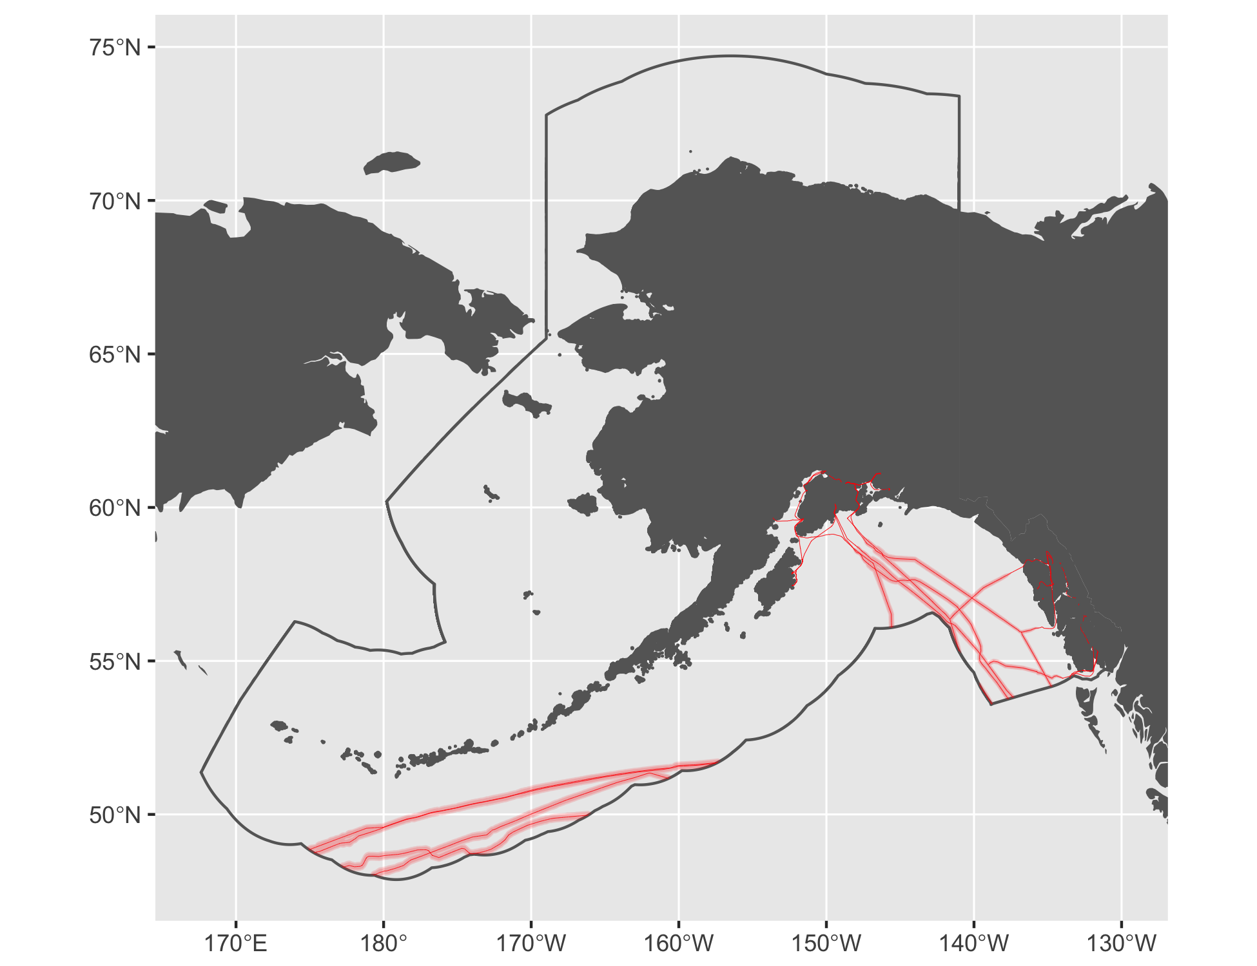

Figure 7 Cable buffers for Alaska.

#### Tidal

See Figure 8.

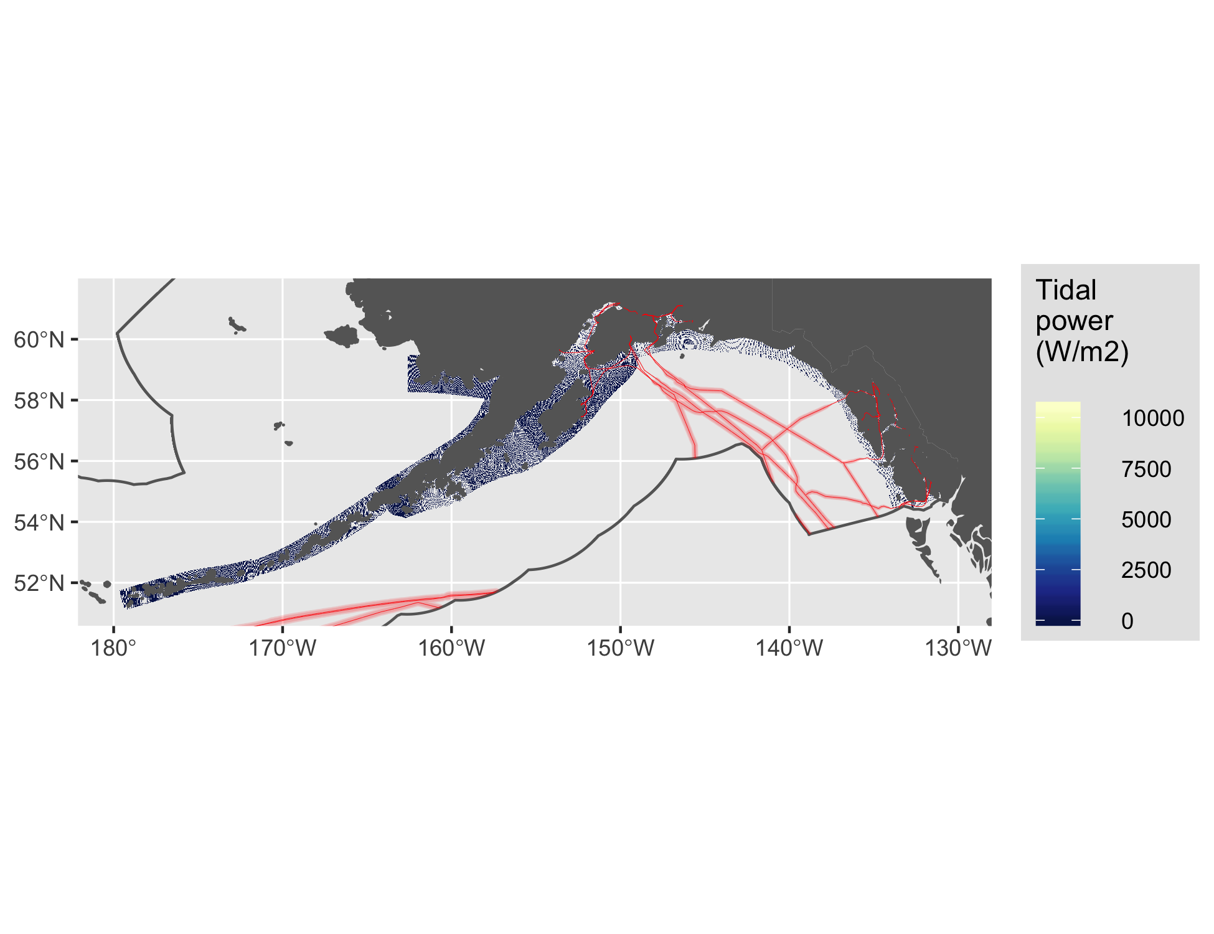

Figure 8 Tidal energy for Alaska.

#### Wave

See Figure 9.

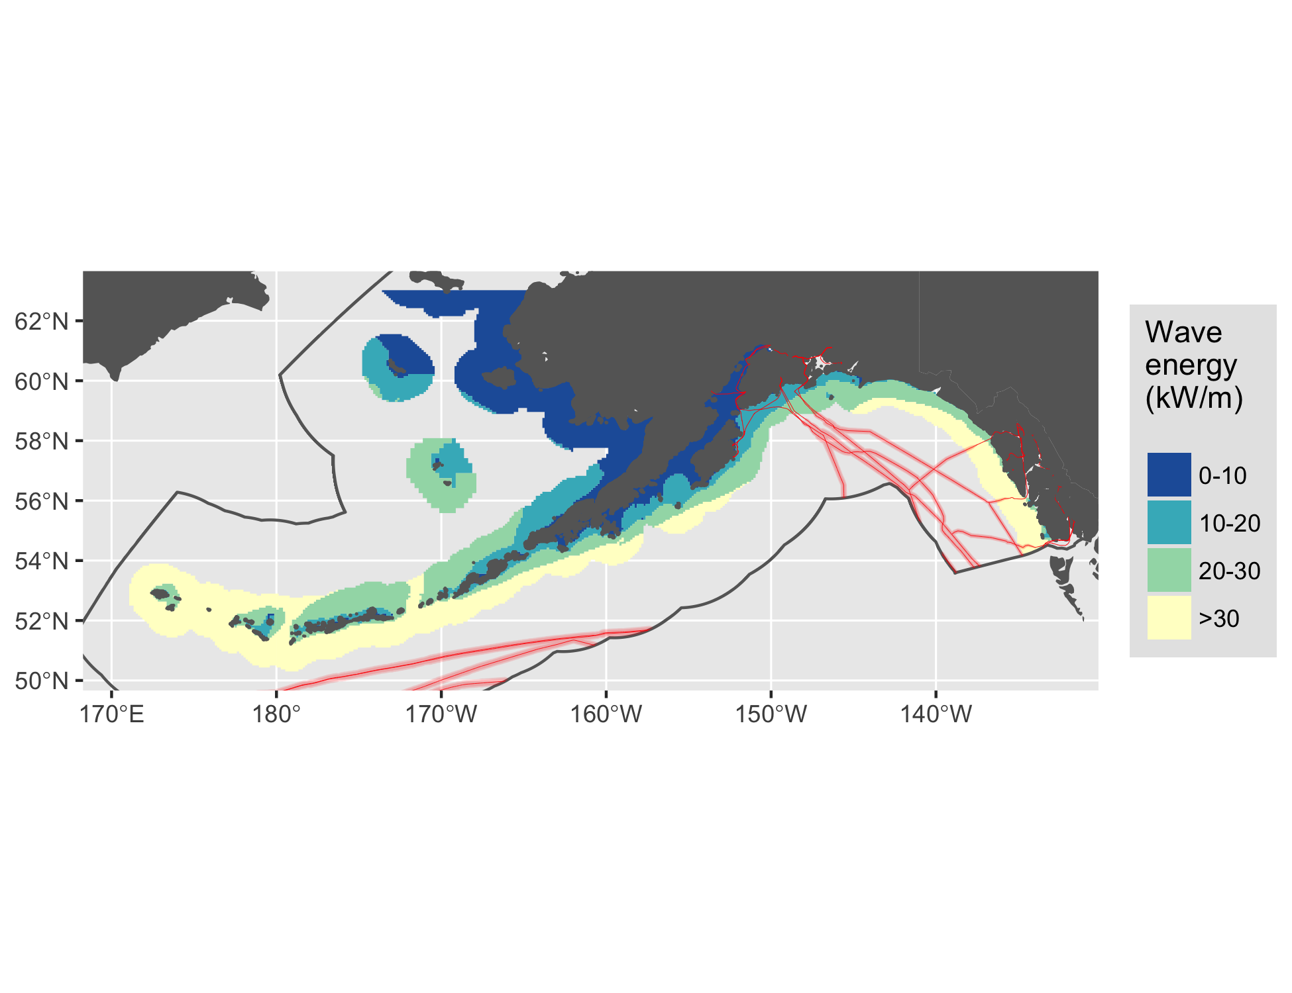

Figure 9 Wave energy for Alaska.

### East

See Figure 10.

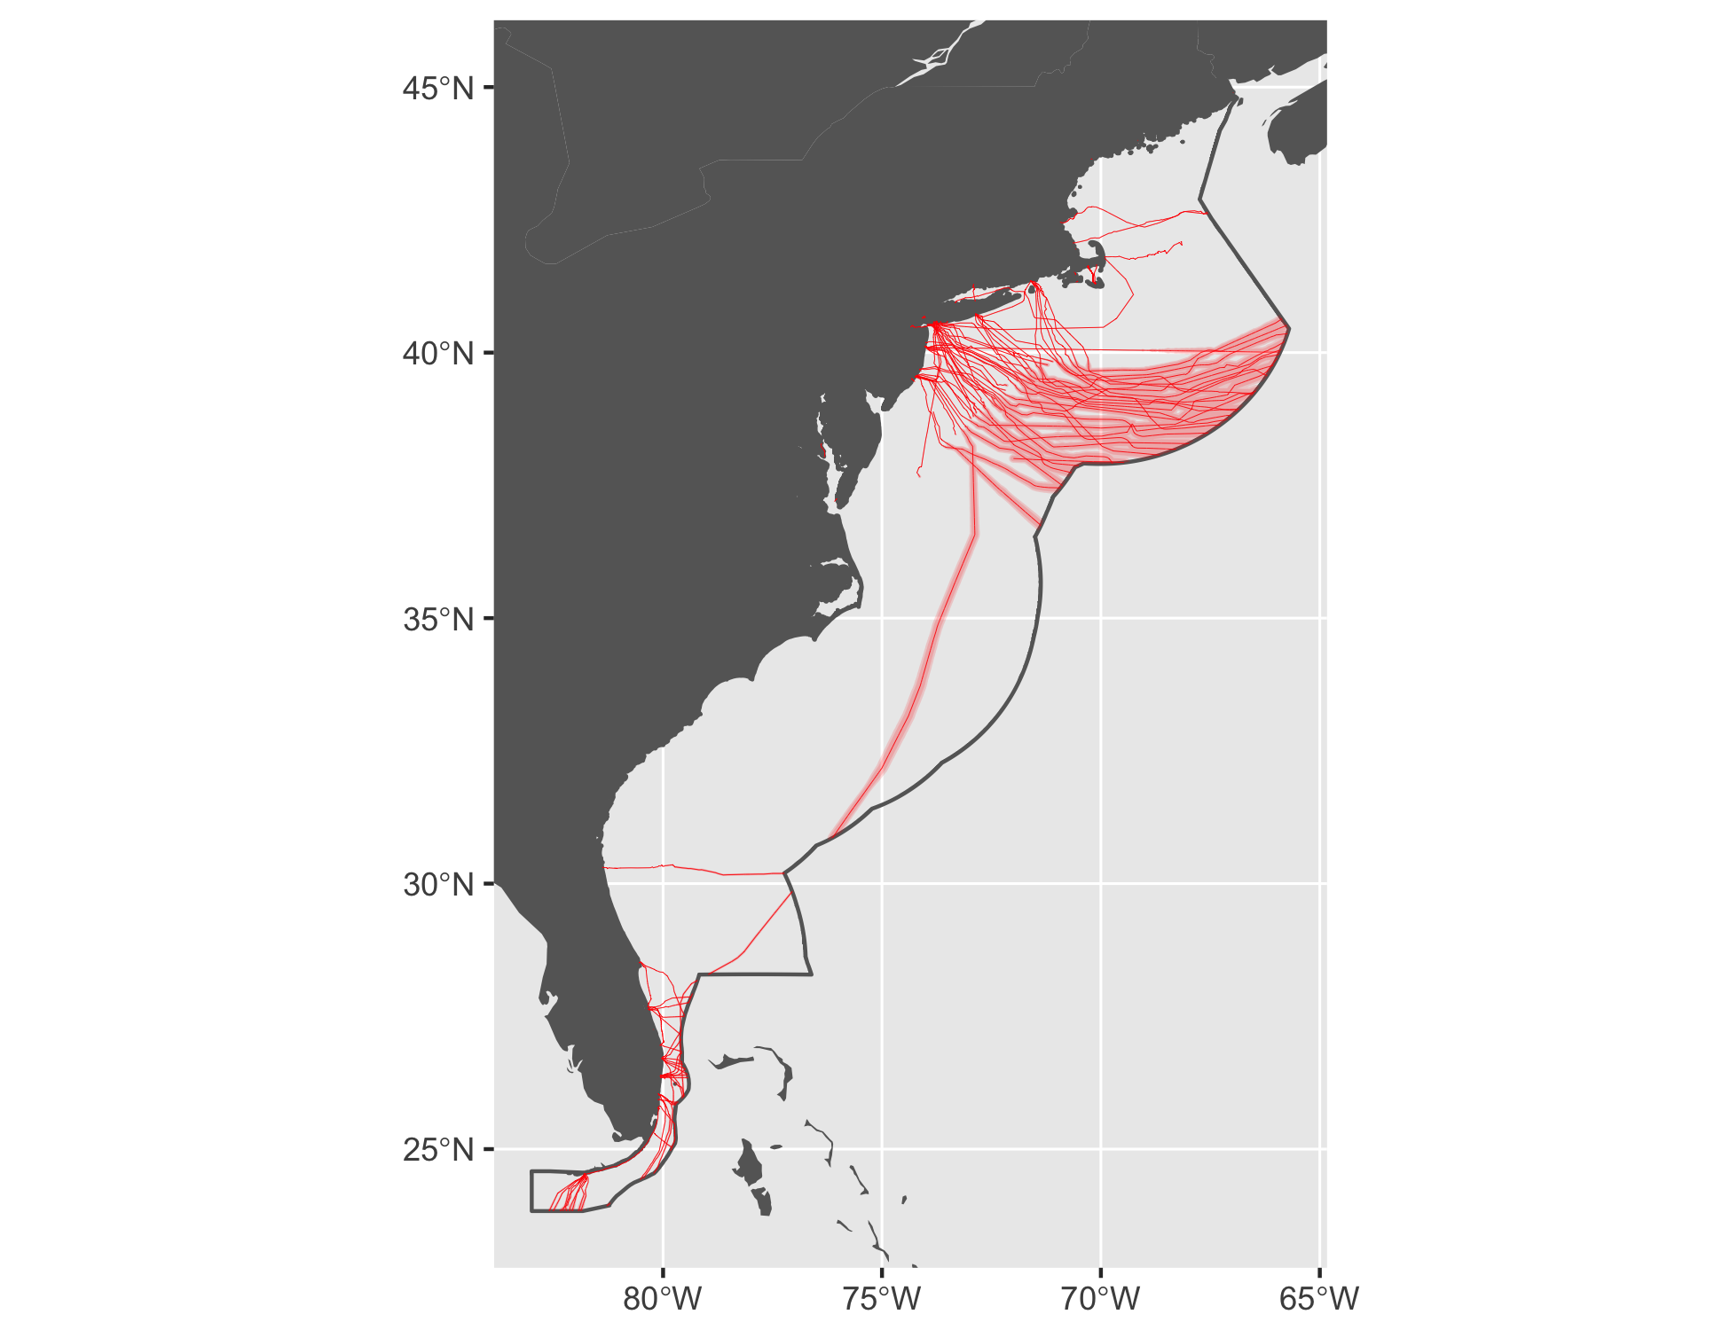

Figure 10 Cable buffers for East Coast.

#### Tidal

See Figure 11.

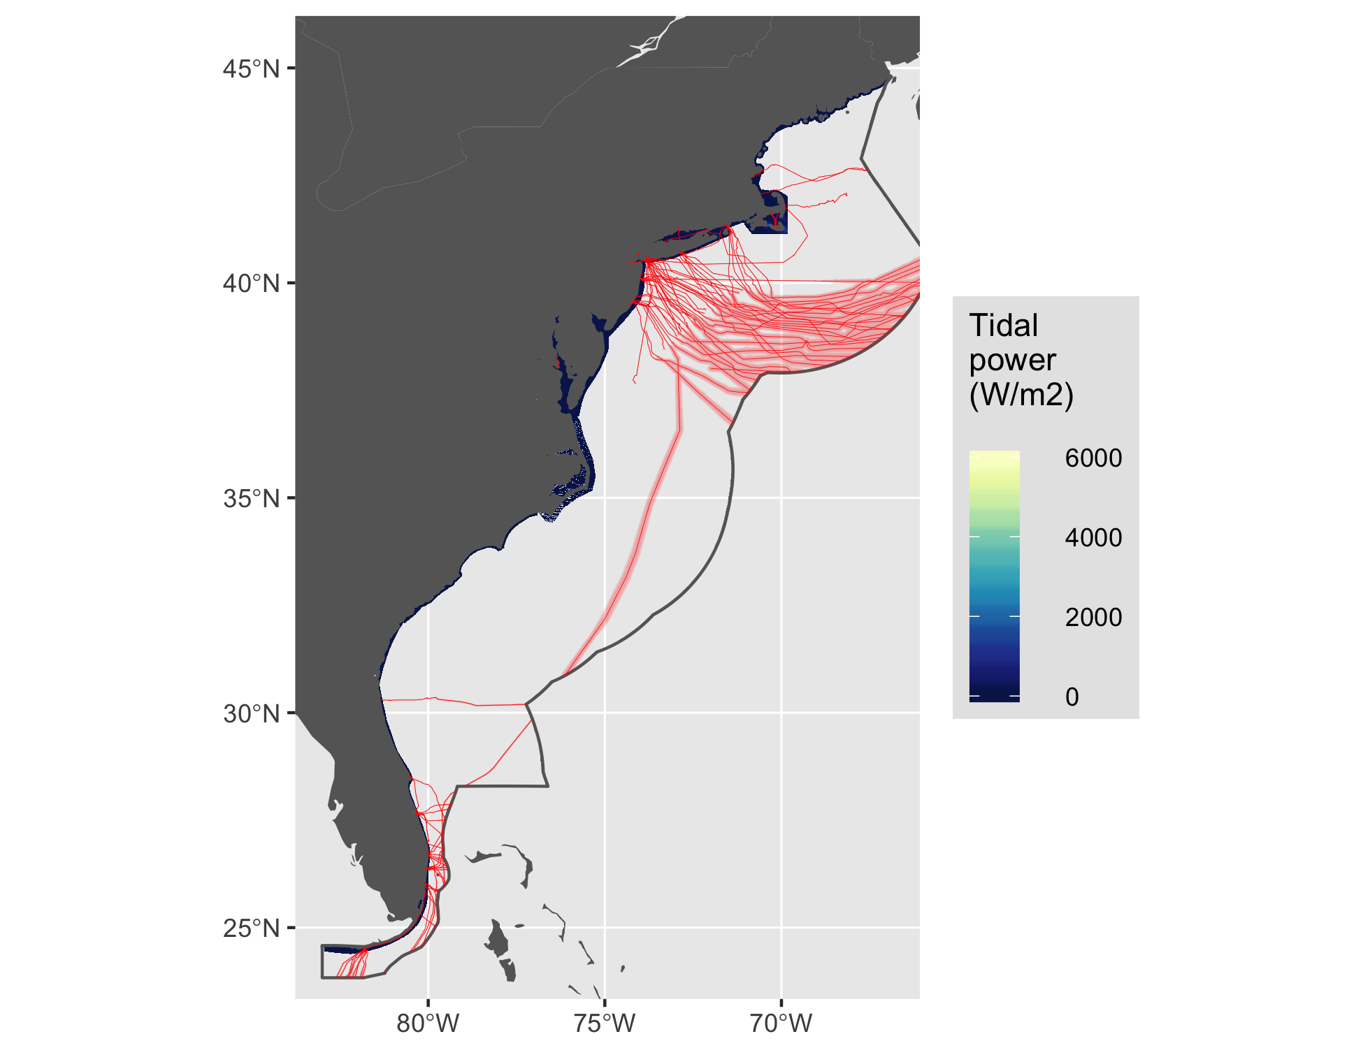

Figure 11 Tidal energy for East.

#### Wave

See Figure 12.

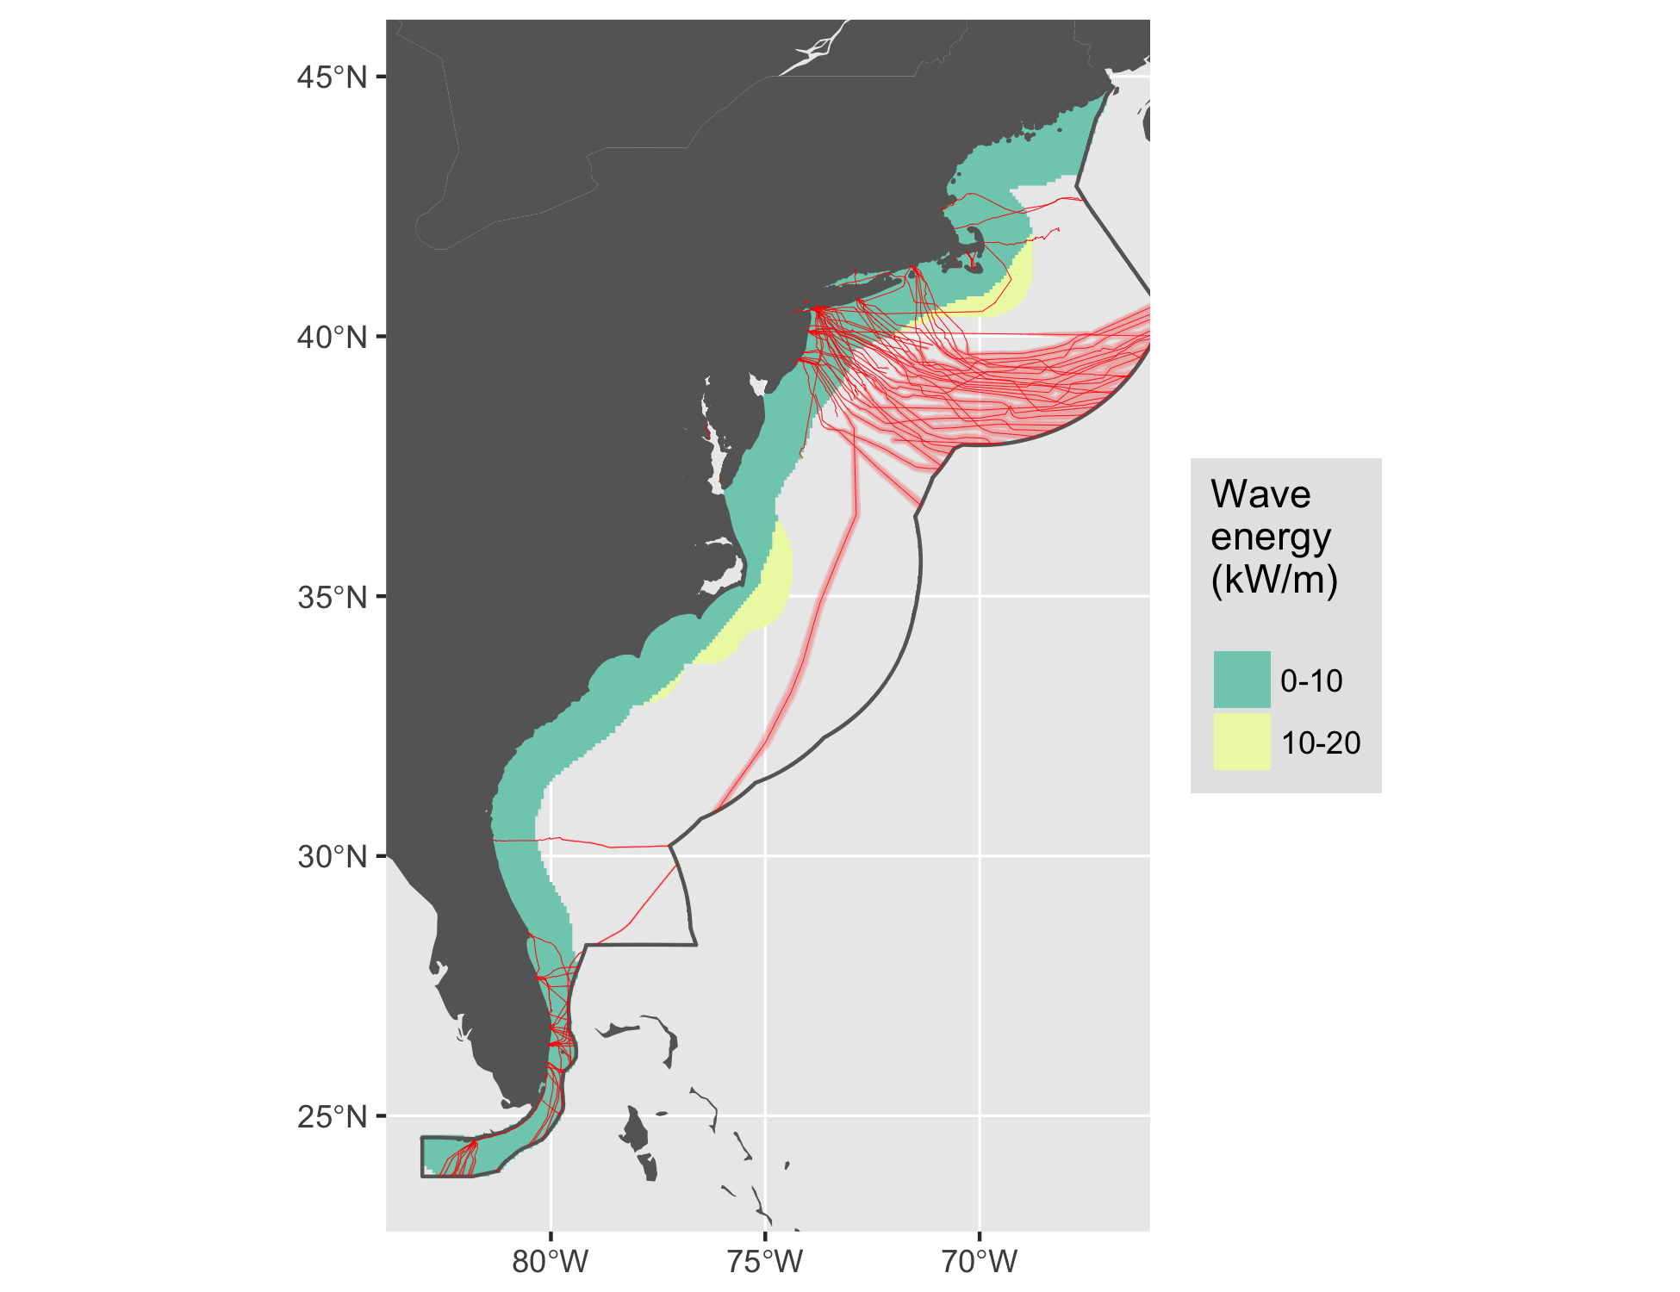

Figure 12 Wave energy for East.

#### Wind

See Figure 13.

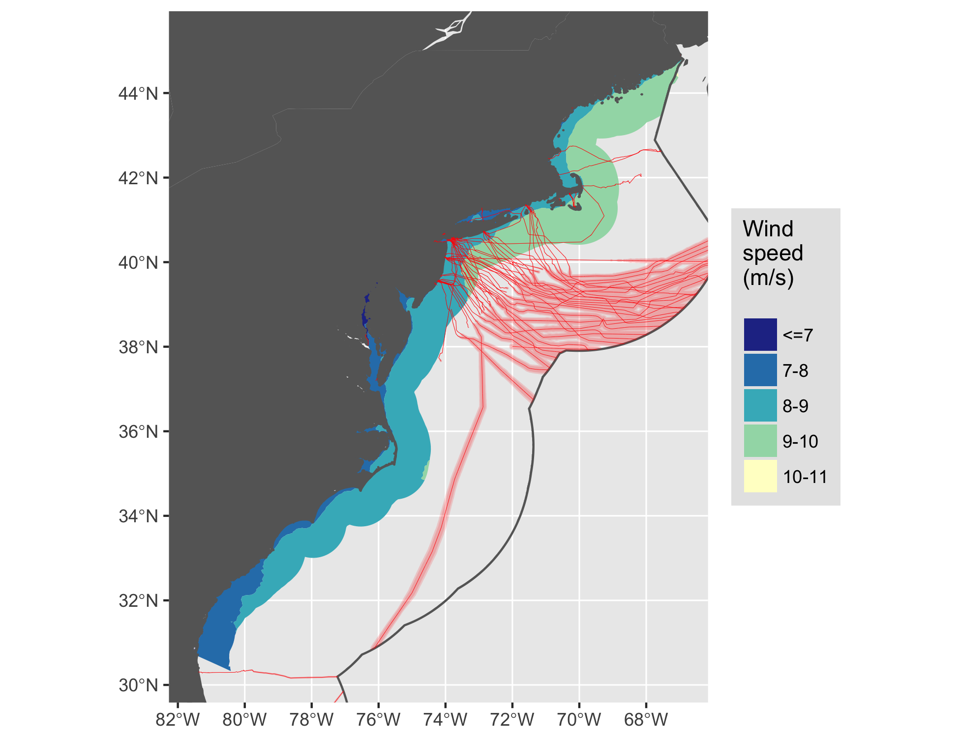

Figure 13 Wind energy for East.

### Guam

See Figure 14.

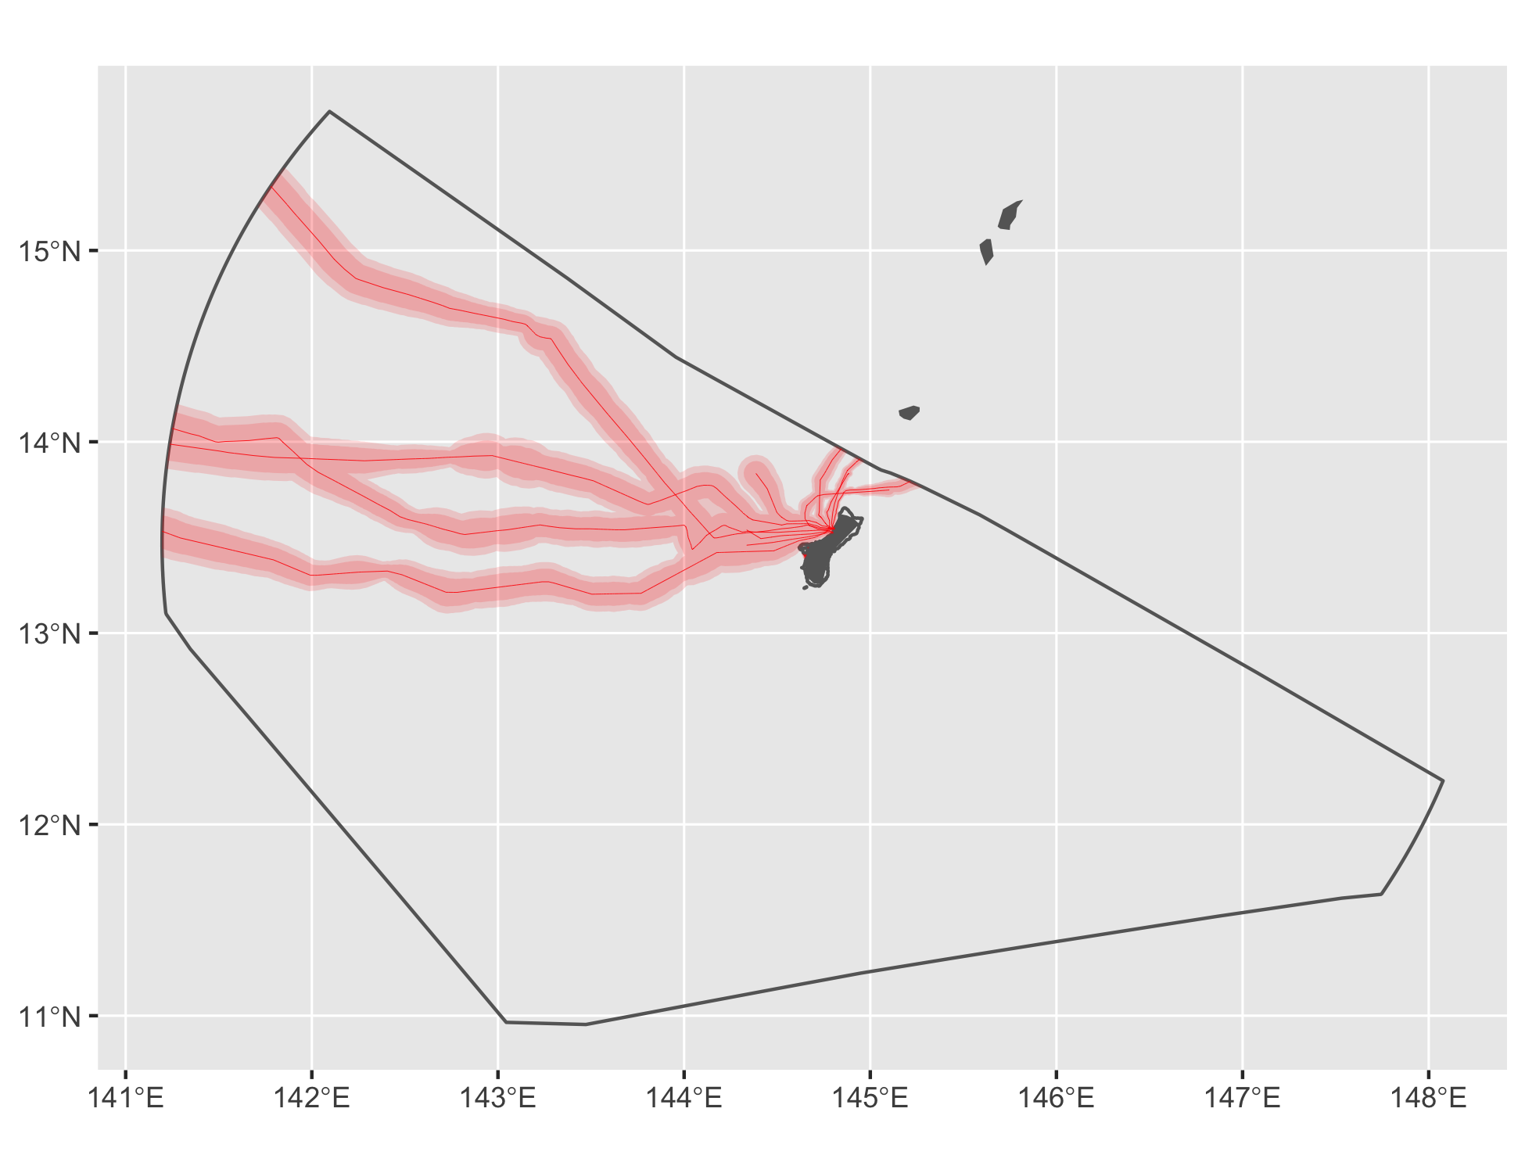

Figure 14 Cable buffers for Guam.

### Gulf of Mexico

See Figure 15.

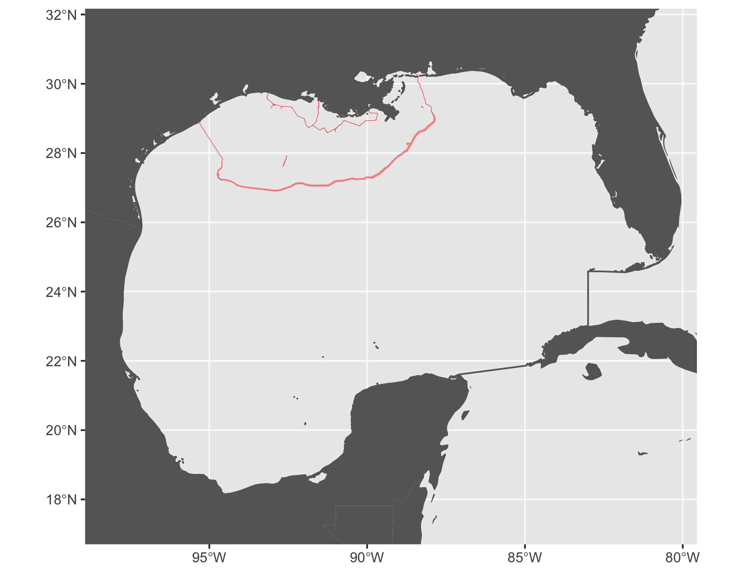

Figure 15 Cable buffers for Gulf of Mexico.

#### Tidal

See Figure 16.

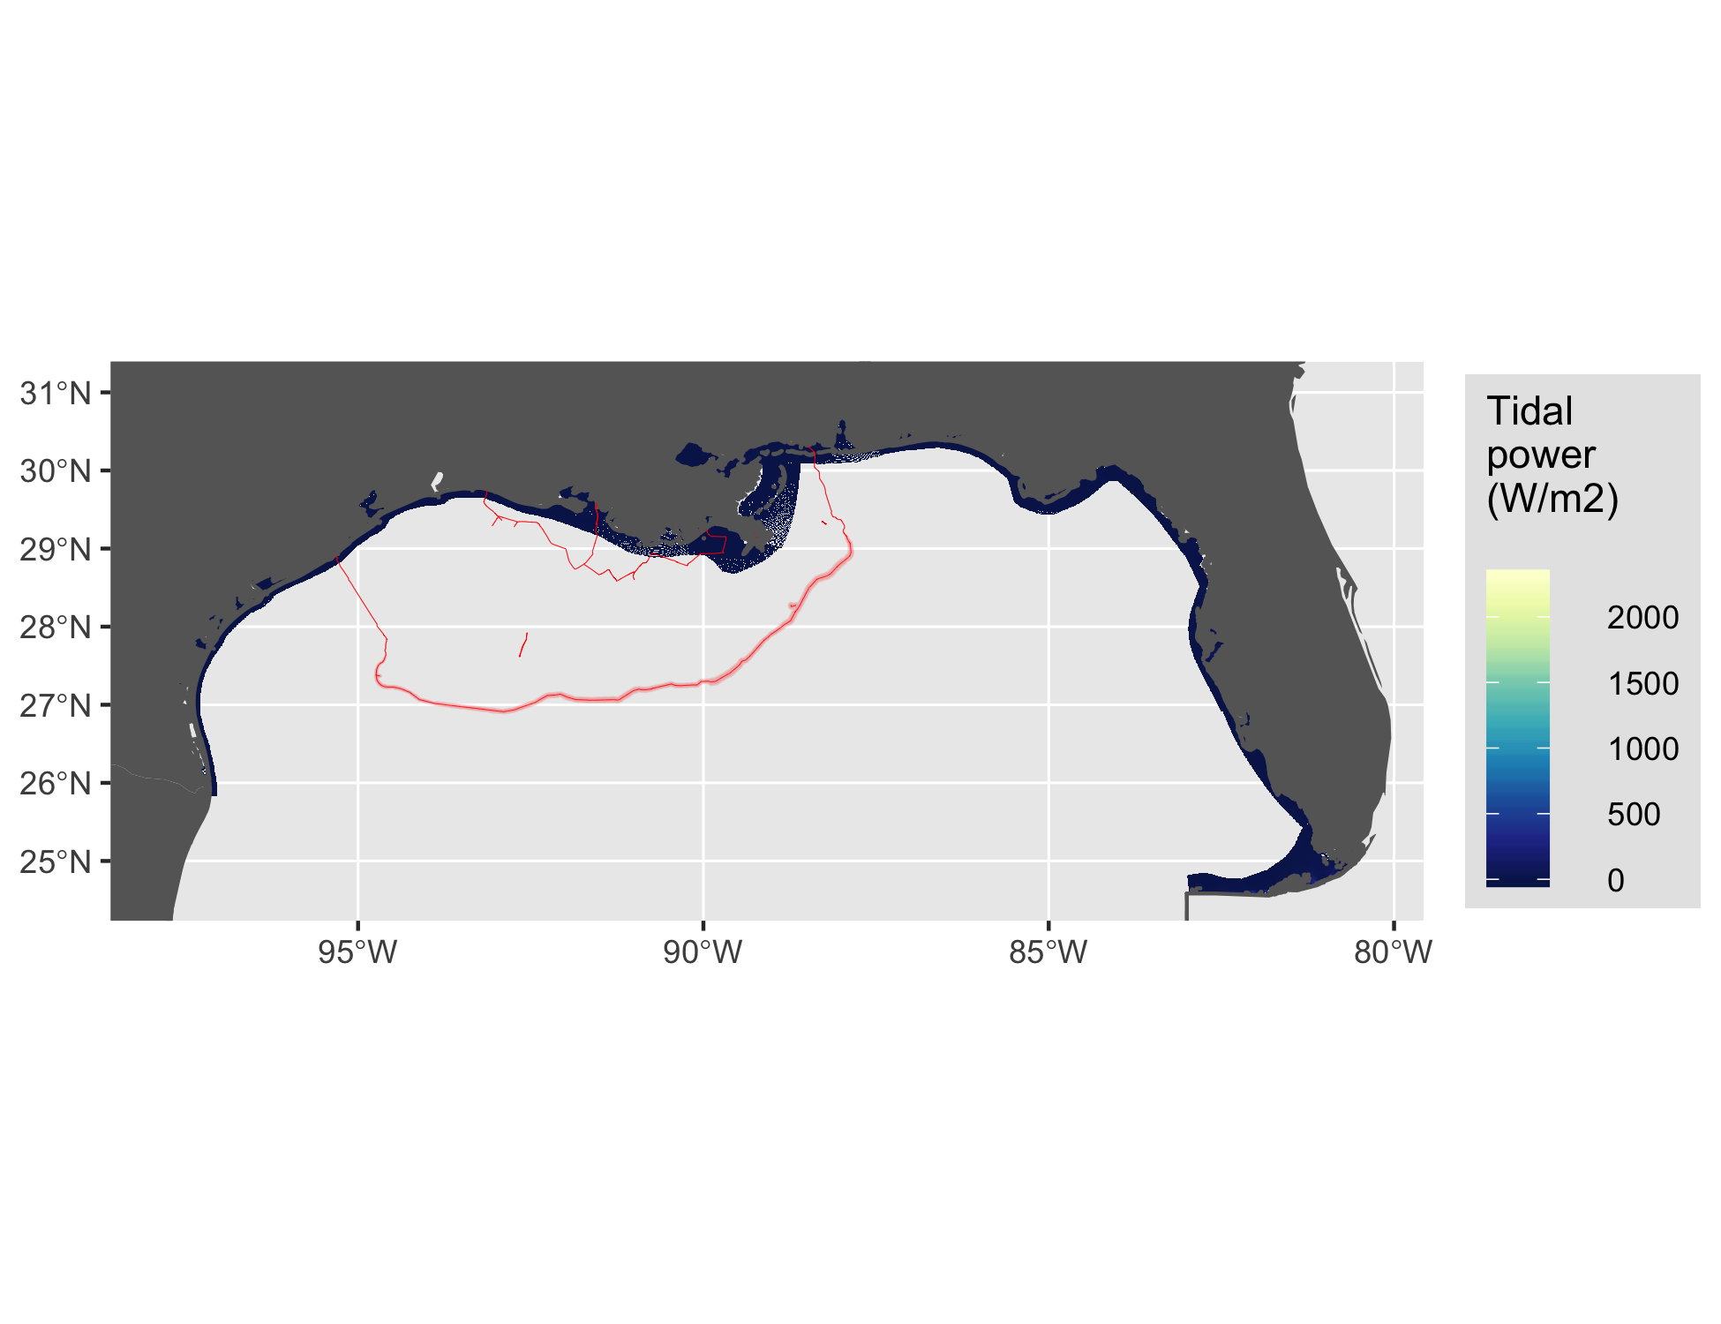

Figure 16 Tidal energy for Gulf of Mexico.

#### Wave

See Figure 17.

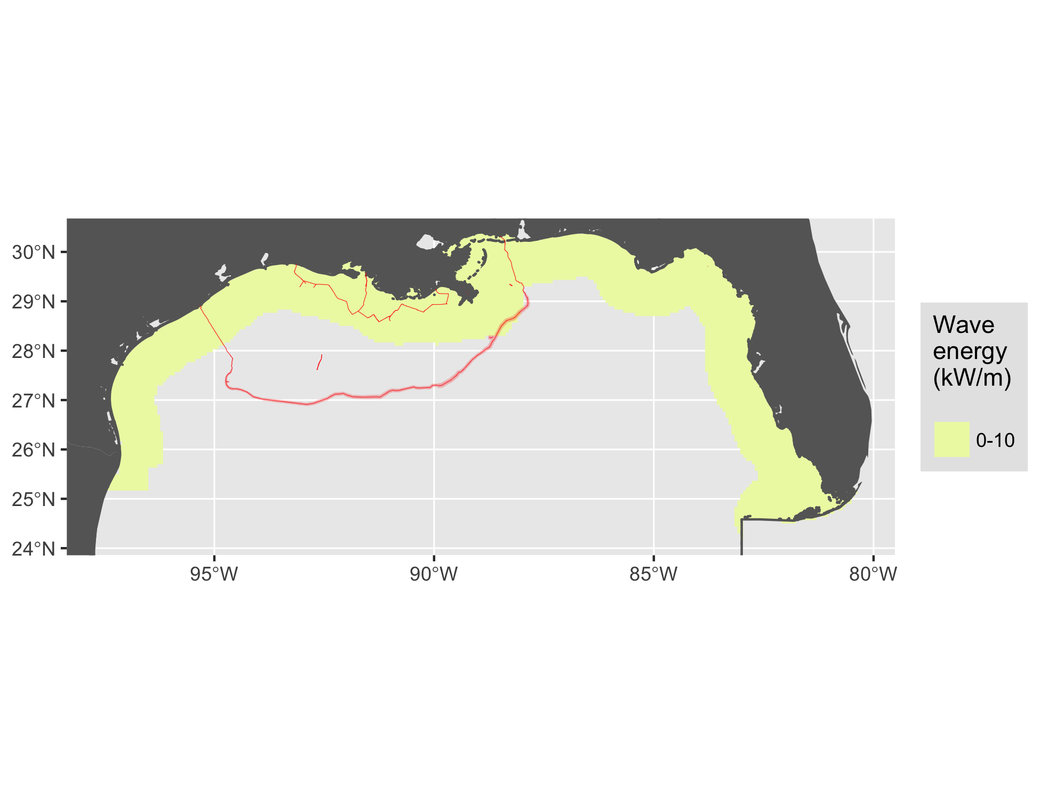

Figure 17 Wave energy for Gulf of Mexico.

#### Wind

See Figure 18.

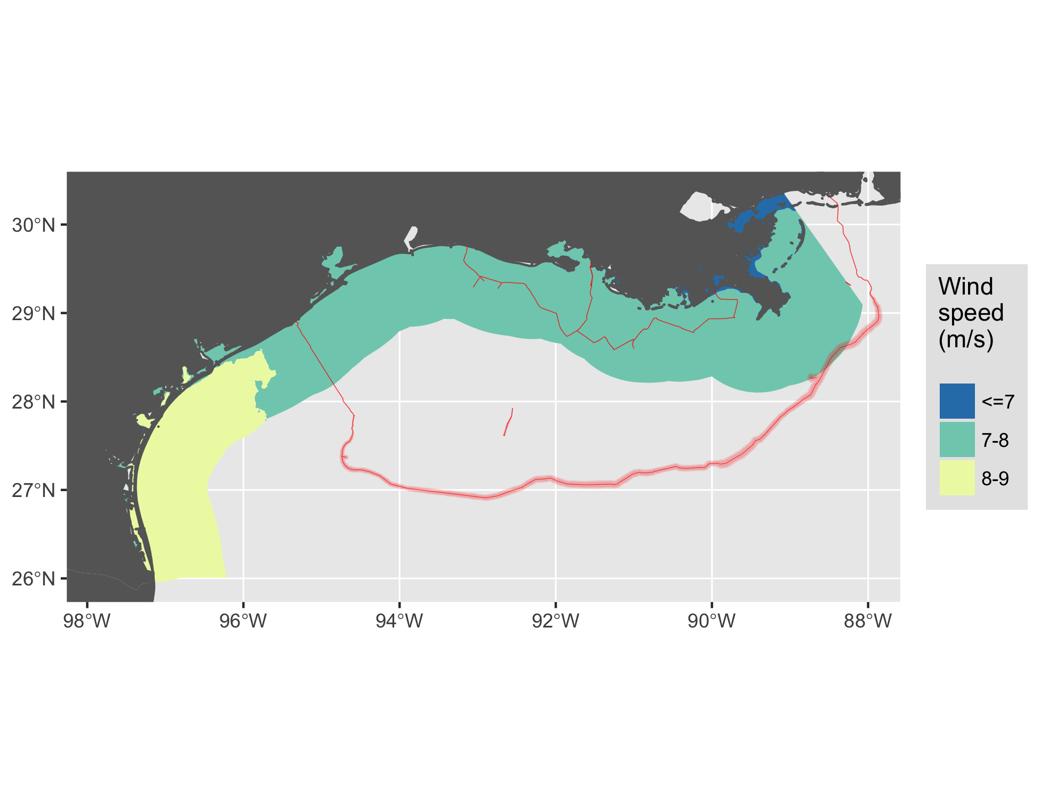

Figure 18 Wind energy for Gulf of Mexico.

### Hawaii

See Figure 19.

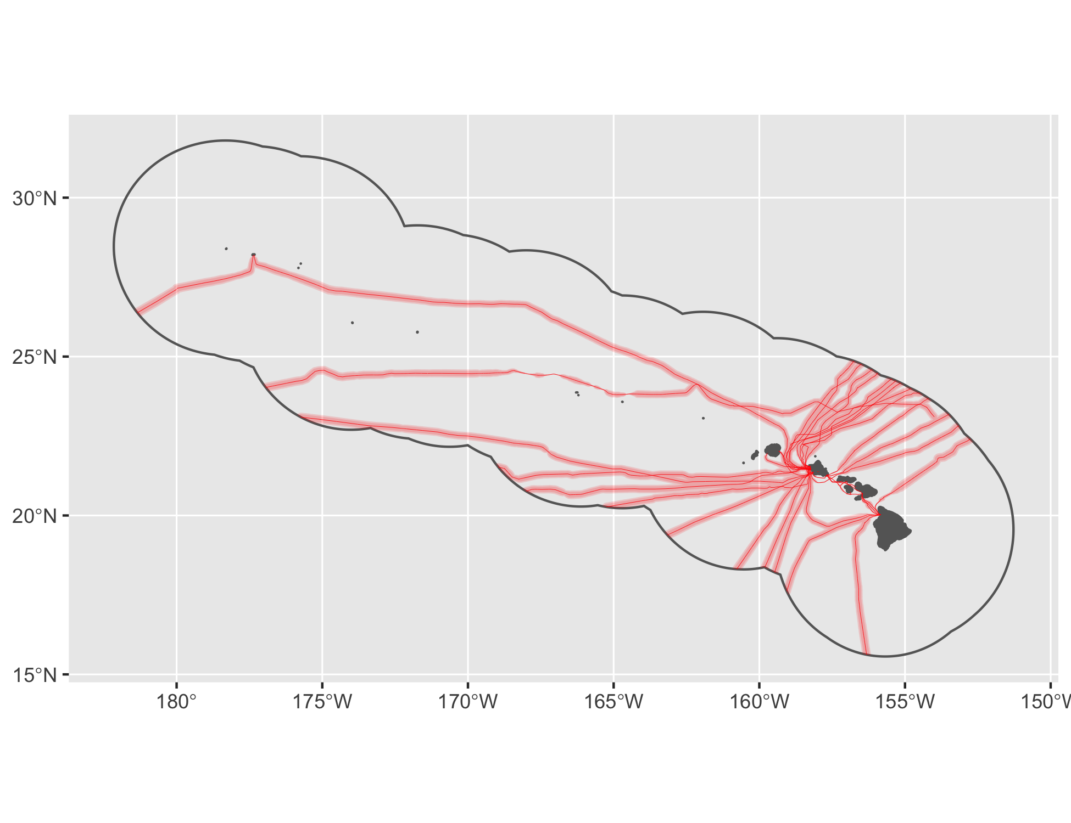

Figure 19 Cable buffers for Hawaii.

#### Wave

See Figure 20.

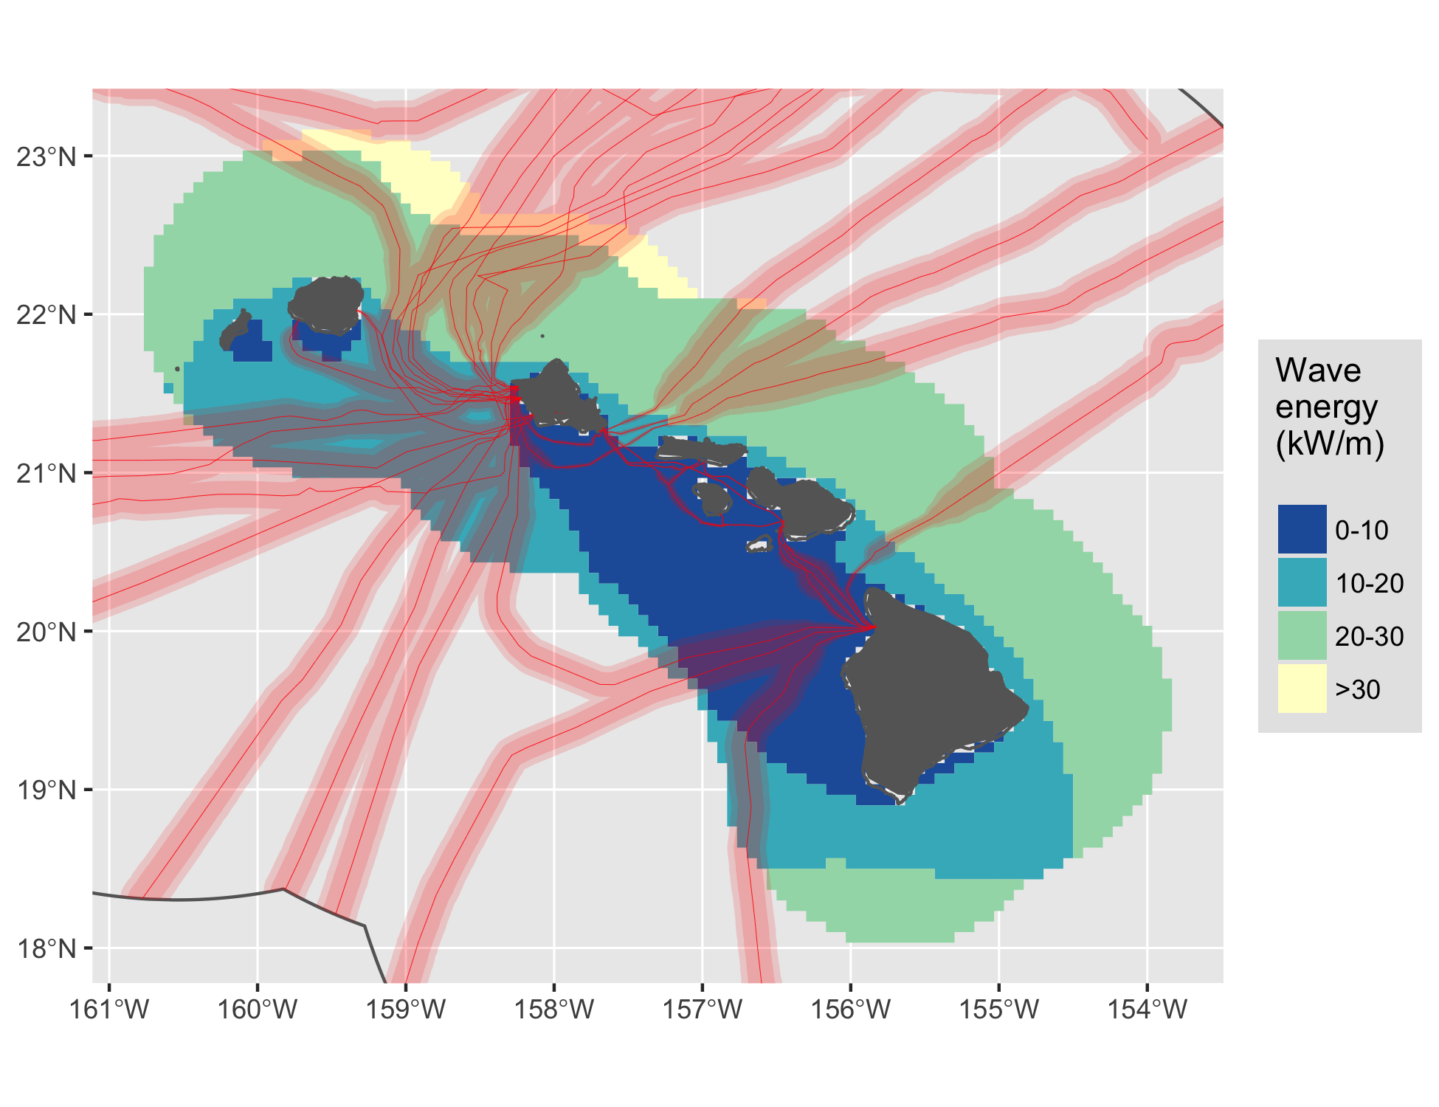

Figure 20 Wave energy for Hawaii.

#### Wind

See Figure 21.

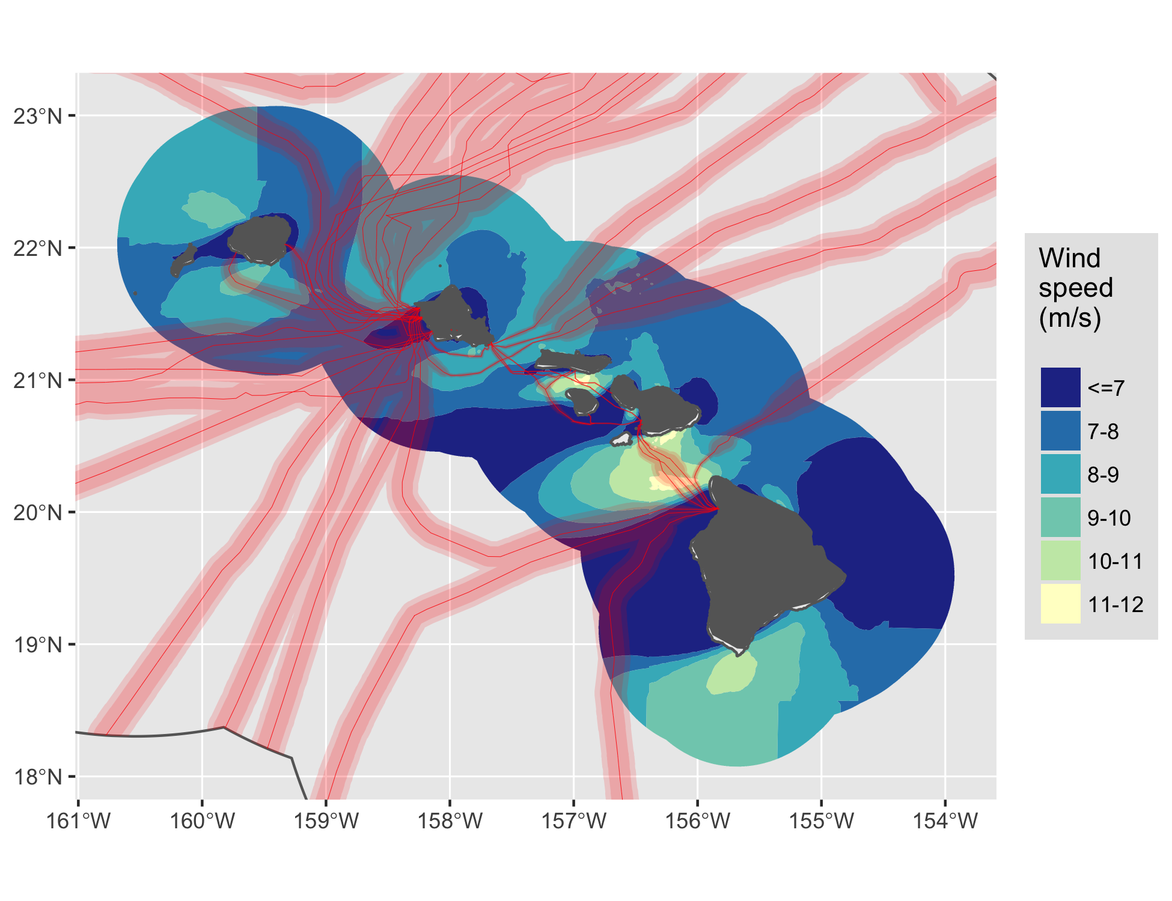

Figure 21 Wind energy for Hawaii.

### Johnston Atoll

See Figure 22.

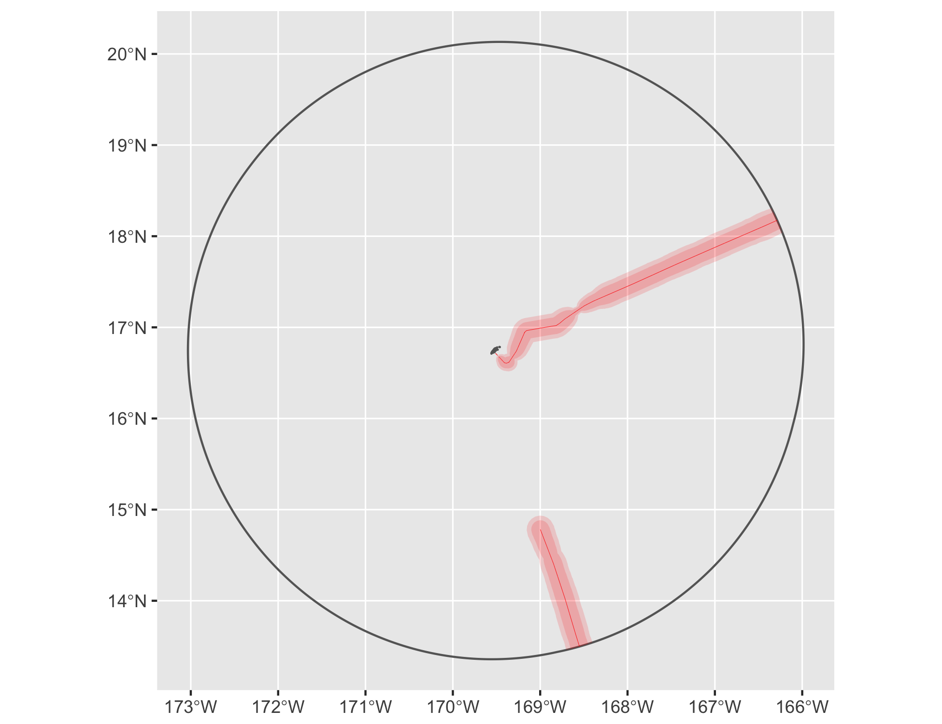

Figure 22 Cable buffers for Johnston Atoll.

### N Mariana Islands

See Figure 23.

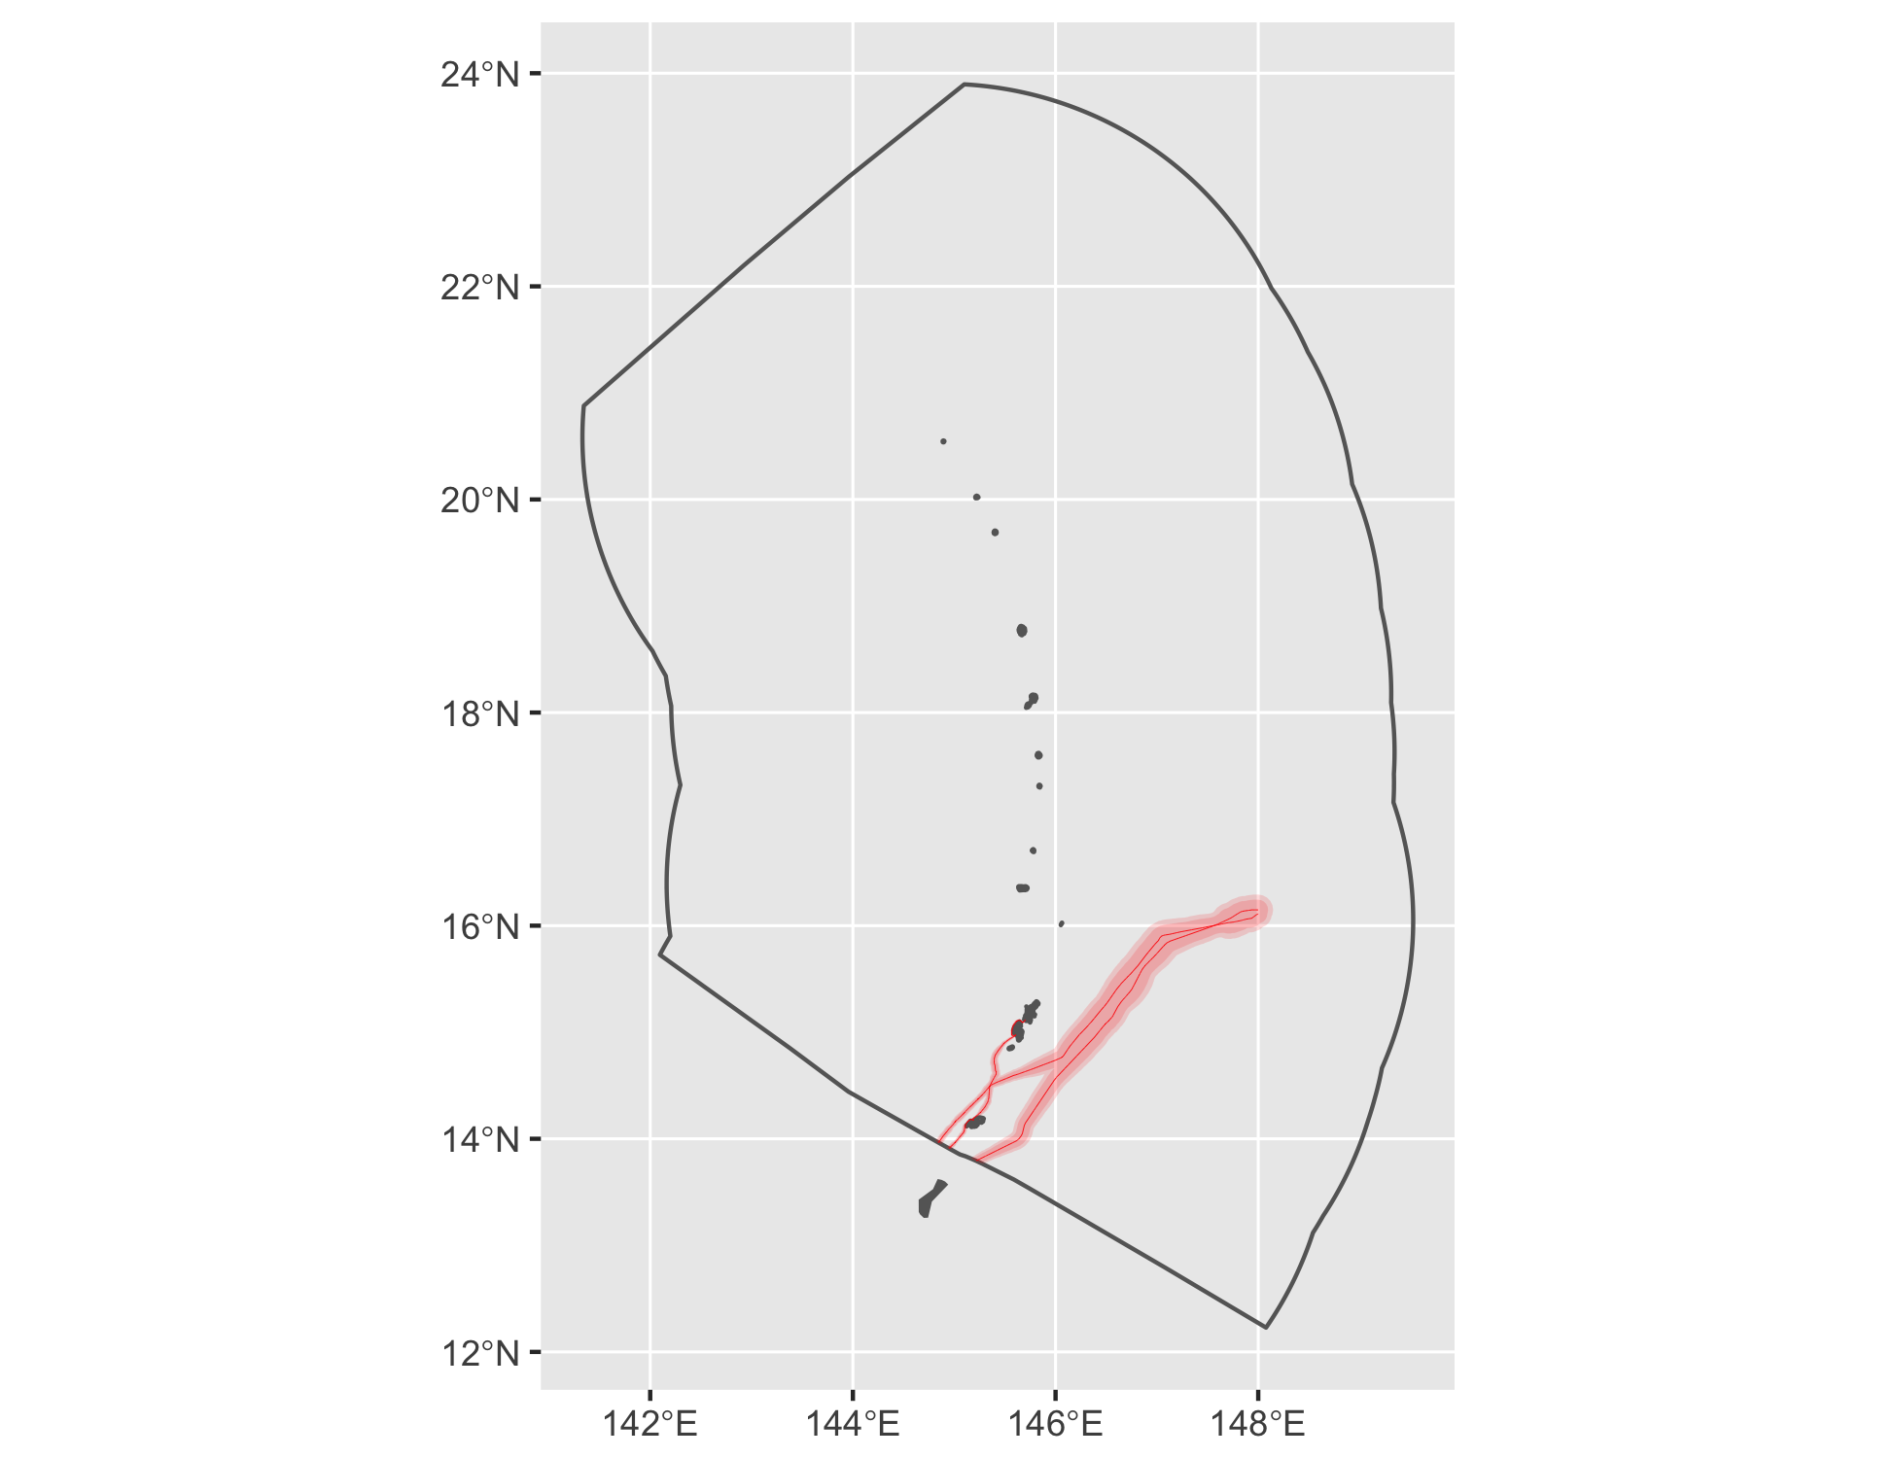

Figure 23 Cable buffers for N Mariana Islands.

### Palmyra Atoll

See Figure 24.

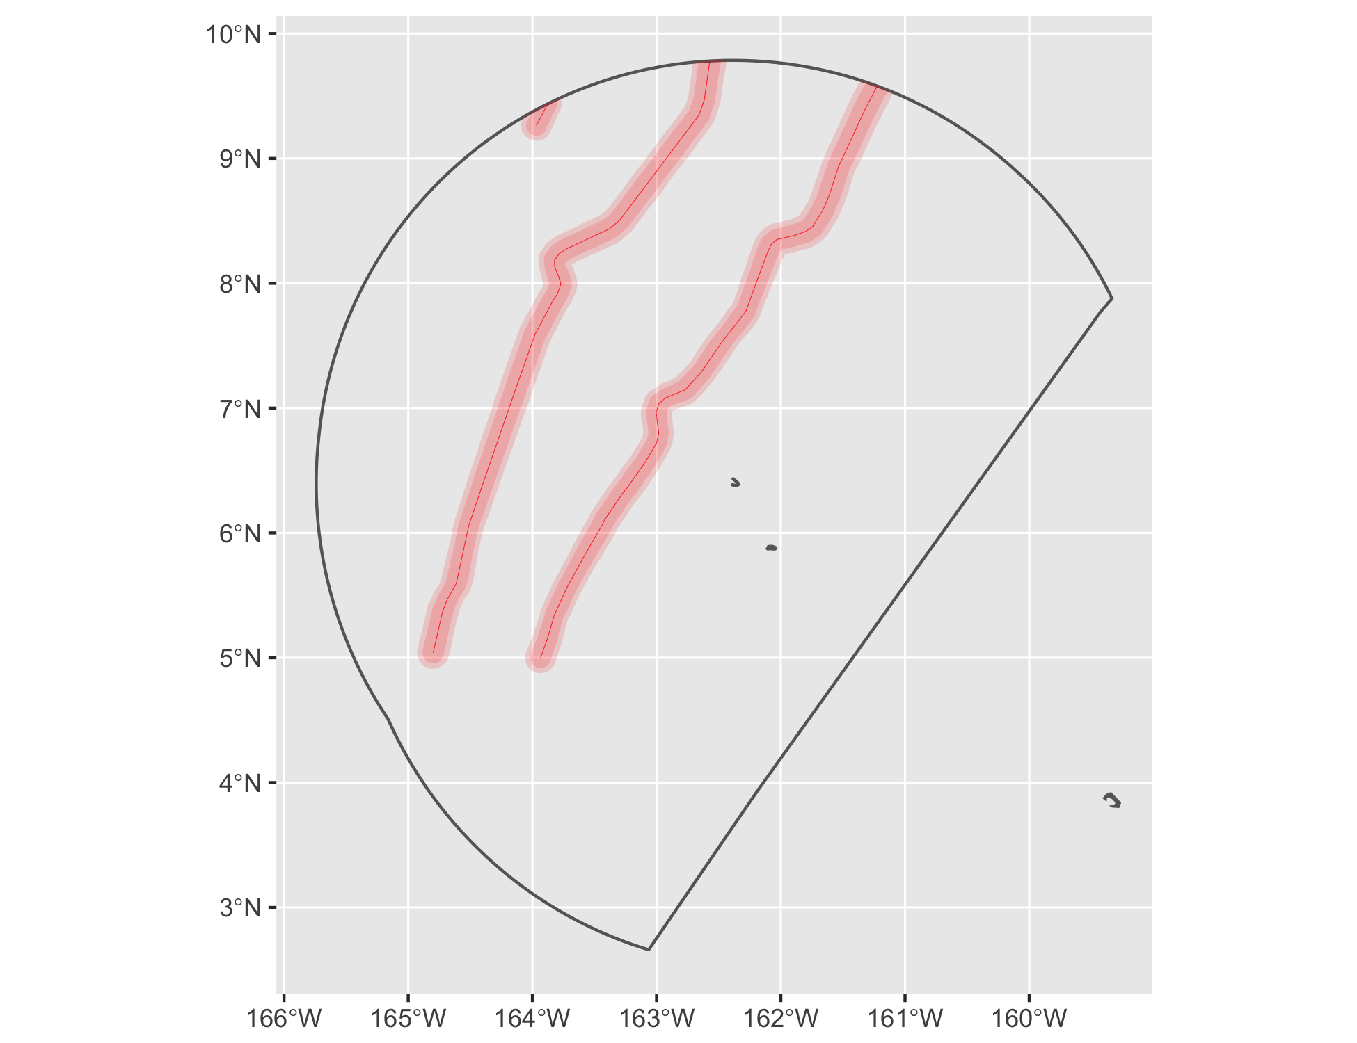

Figure 24 Cable buffers for Palmyra Atoll.

### Puerto Rico

See Figure 25.

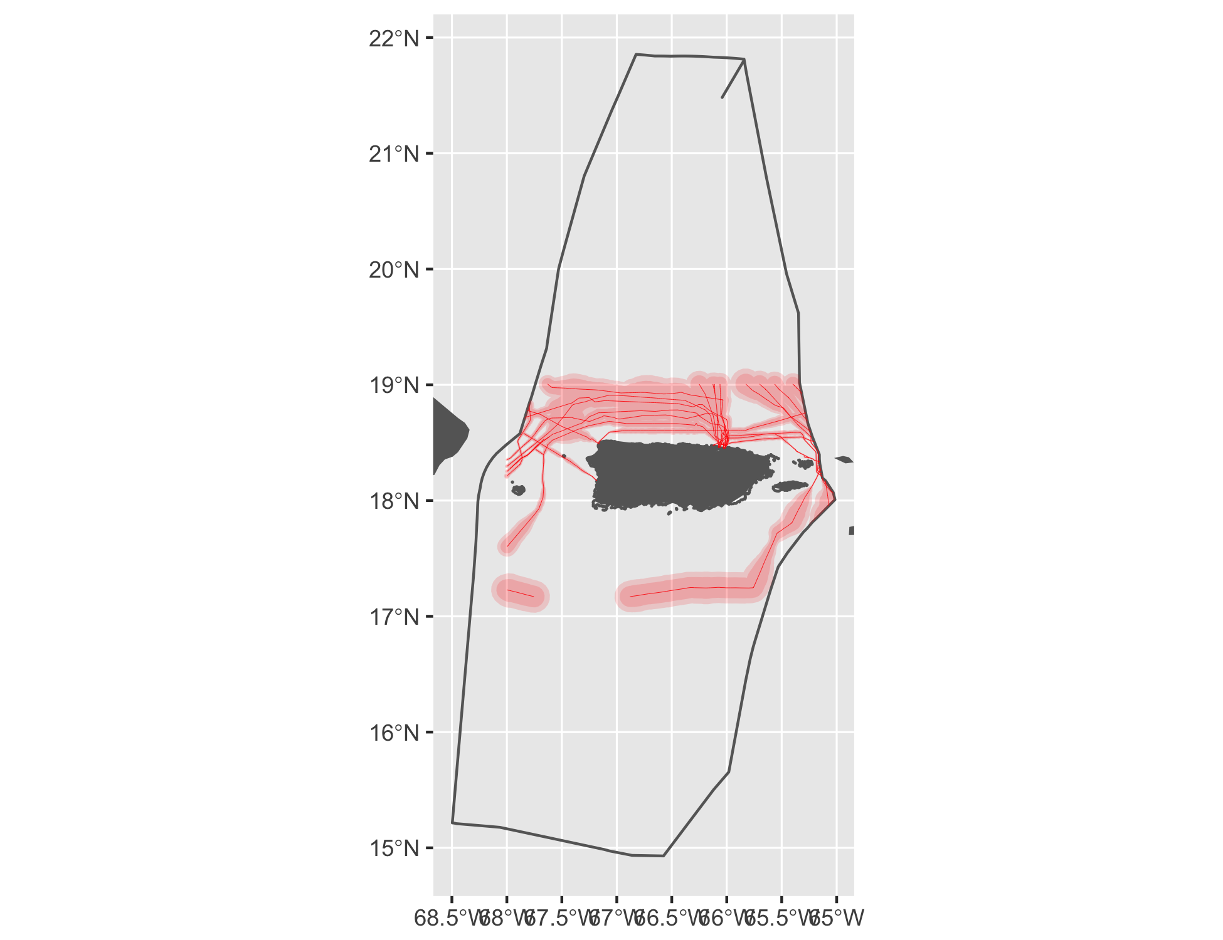

Figure 25 Cable buffers for Puerto Rico.

#### Tidal

See Figure 26.

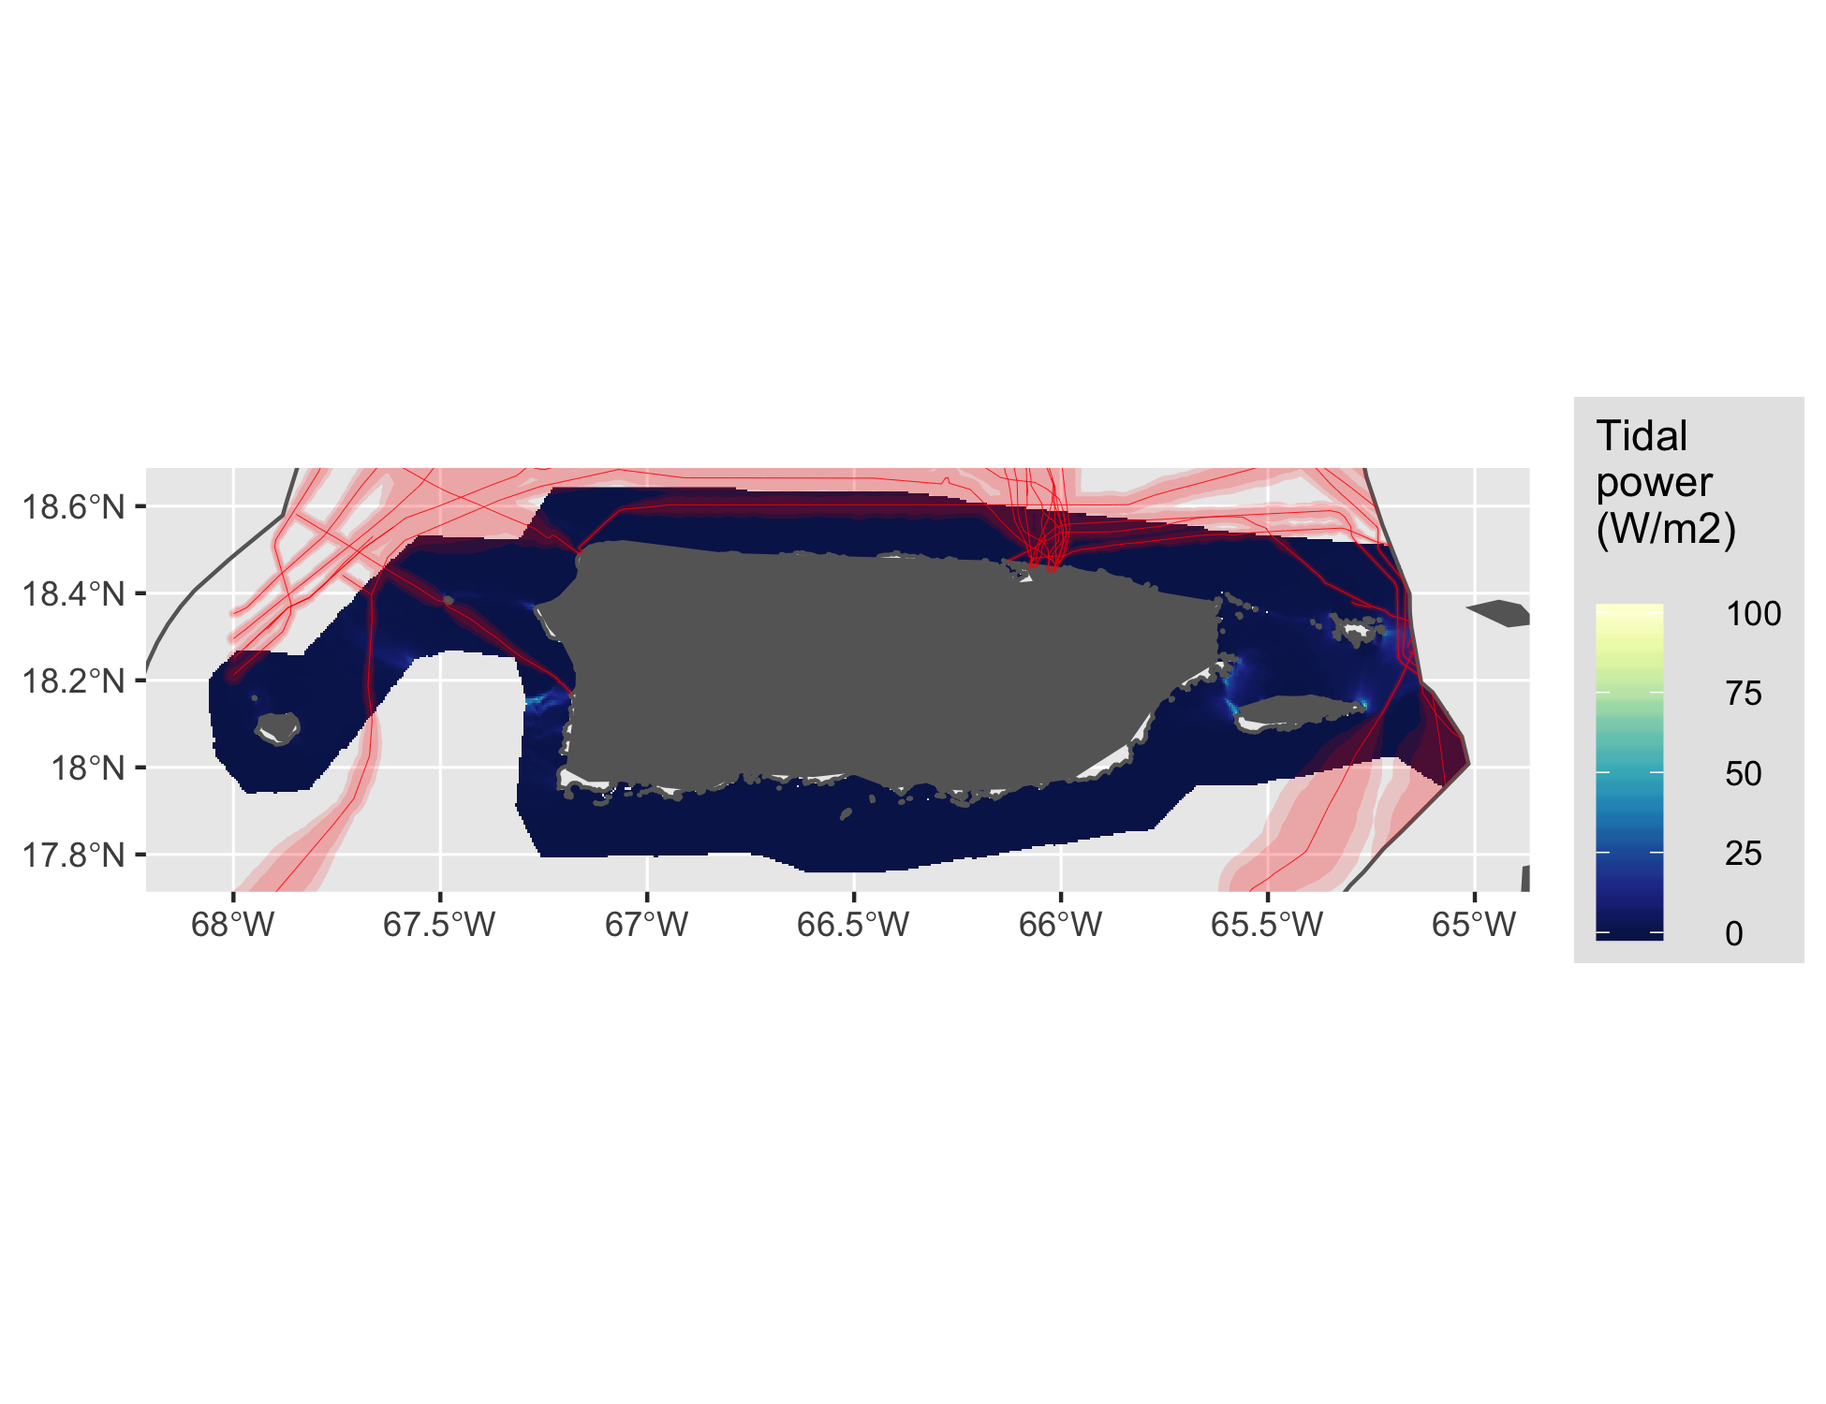

Figure 26 Tidal energy for Puerto Rico.

#### Wave

See Figure 27.

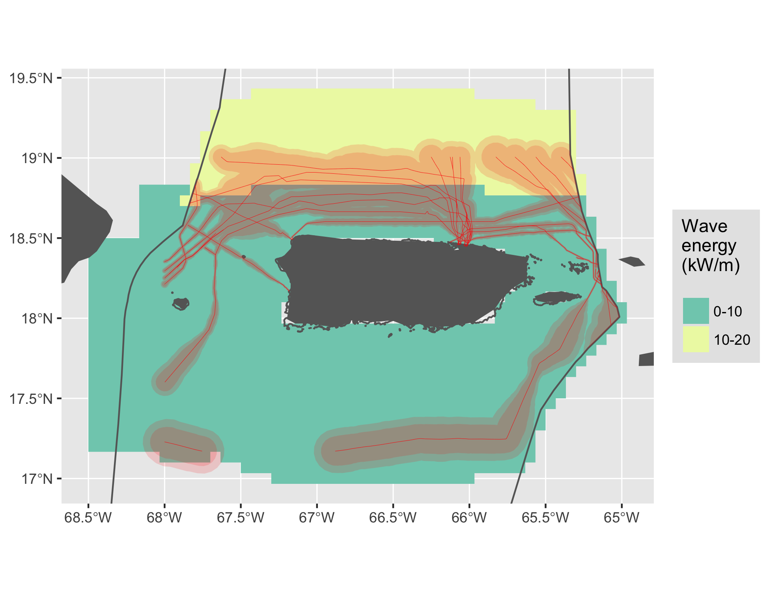

Figure 27 Wave energy for Puerto Rico.

### US Virgin Islands

See Figure 28.

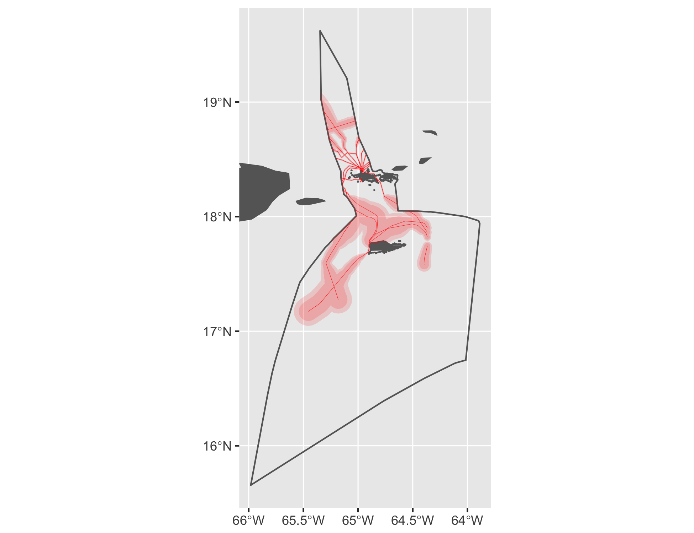

Figure 28 Cable buffers for US Virgin Islands.

#### Tidal

See Figure 29.

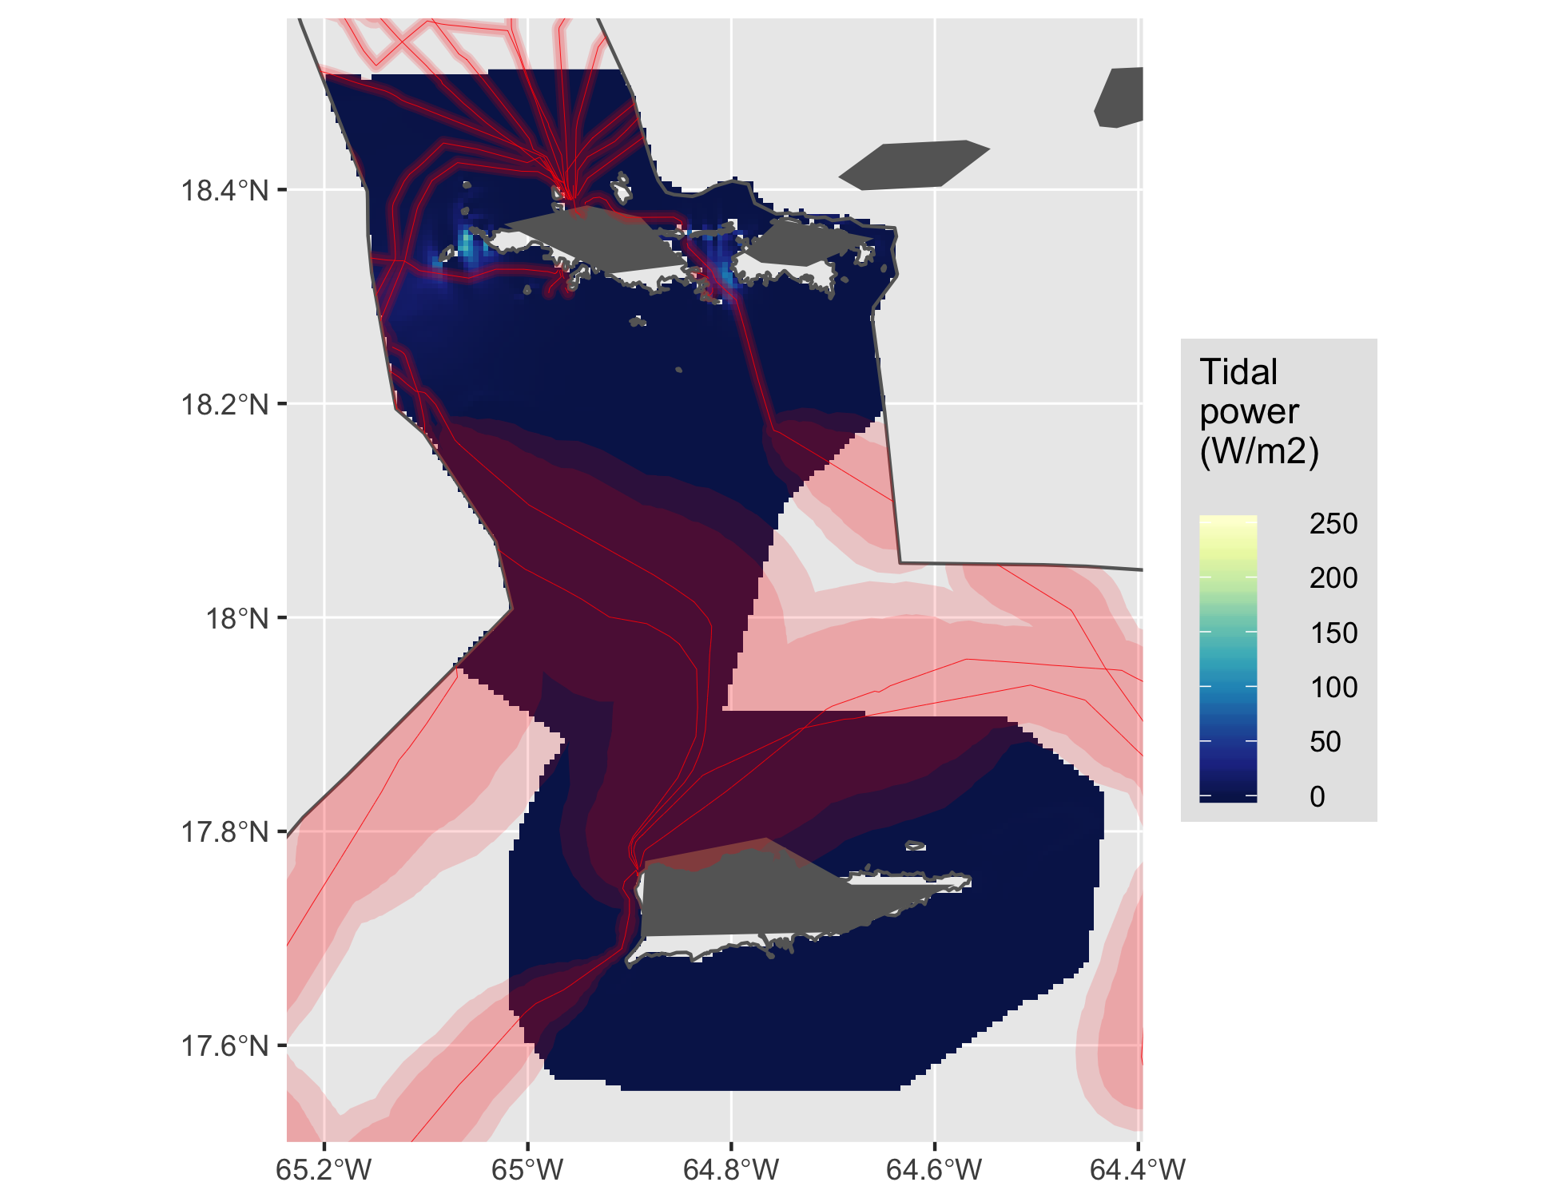

Figure 29 Tidal energy for US Virgin Islands.

#### Wave

See Figure 30.

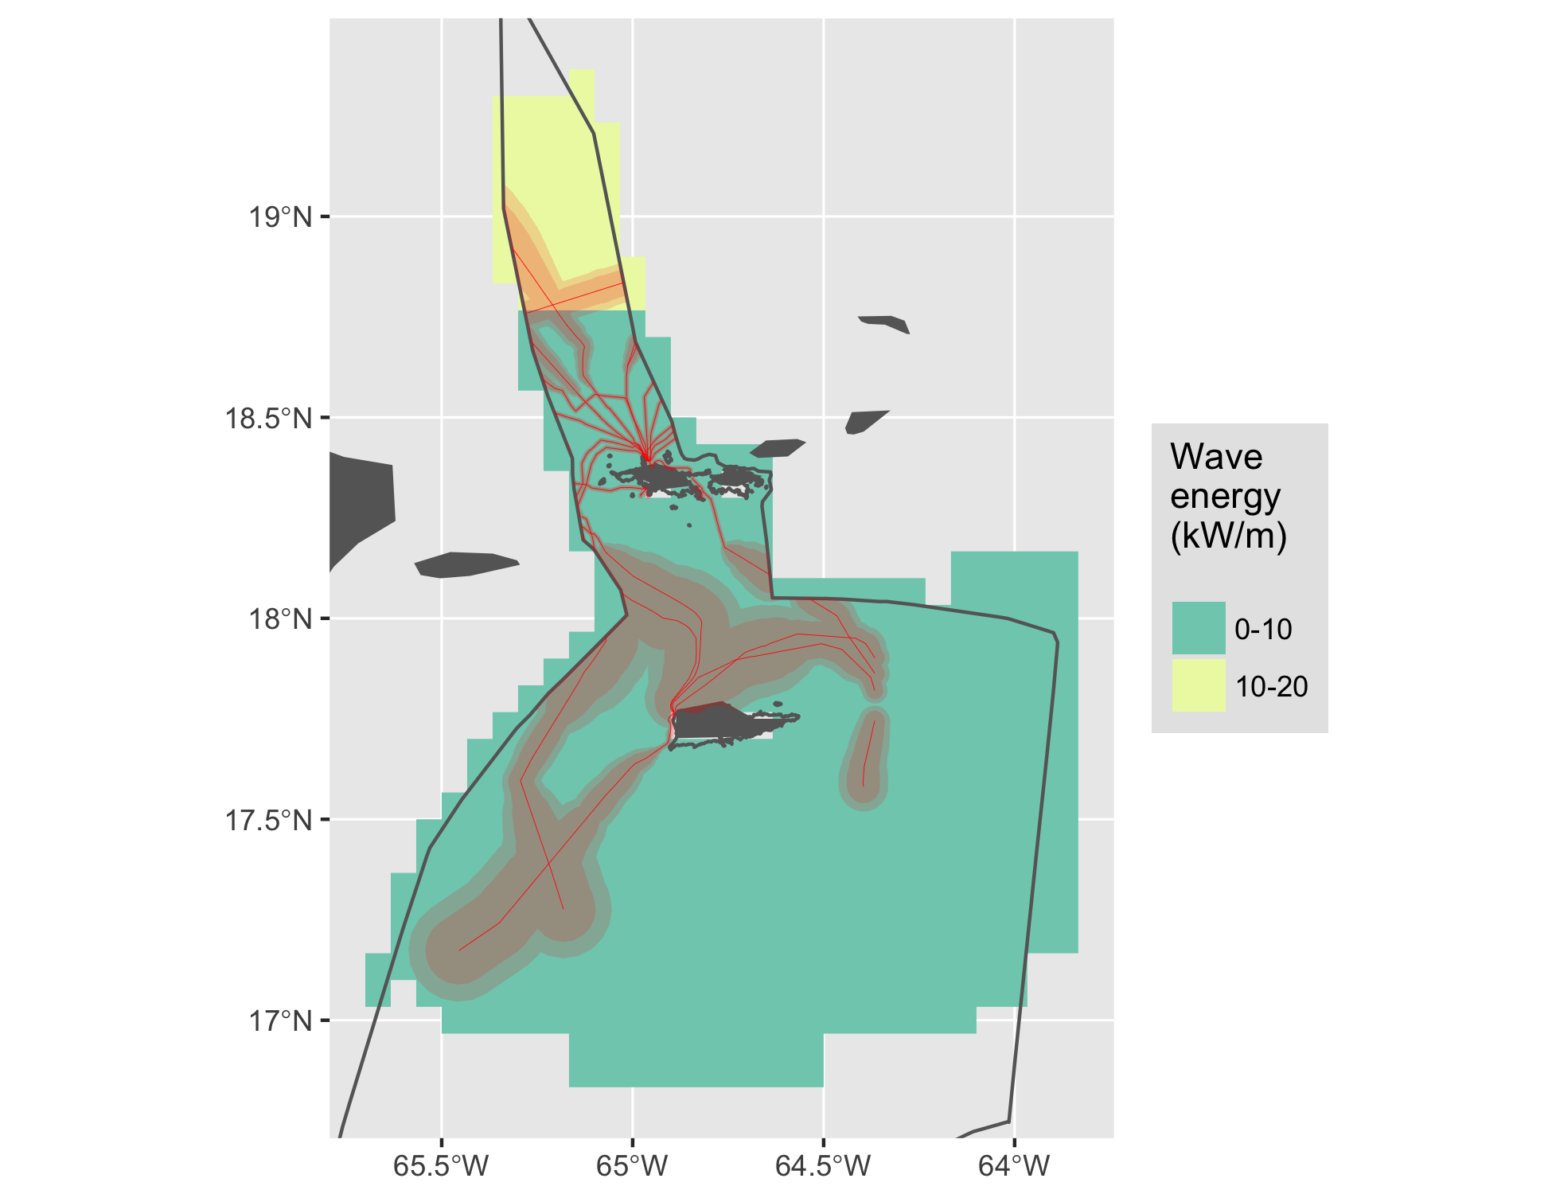

Figure 30 Wave energy for US Virgin Islands.

### Wake Island

See Figure 31.

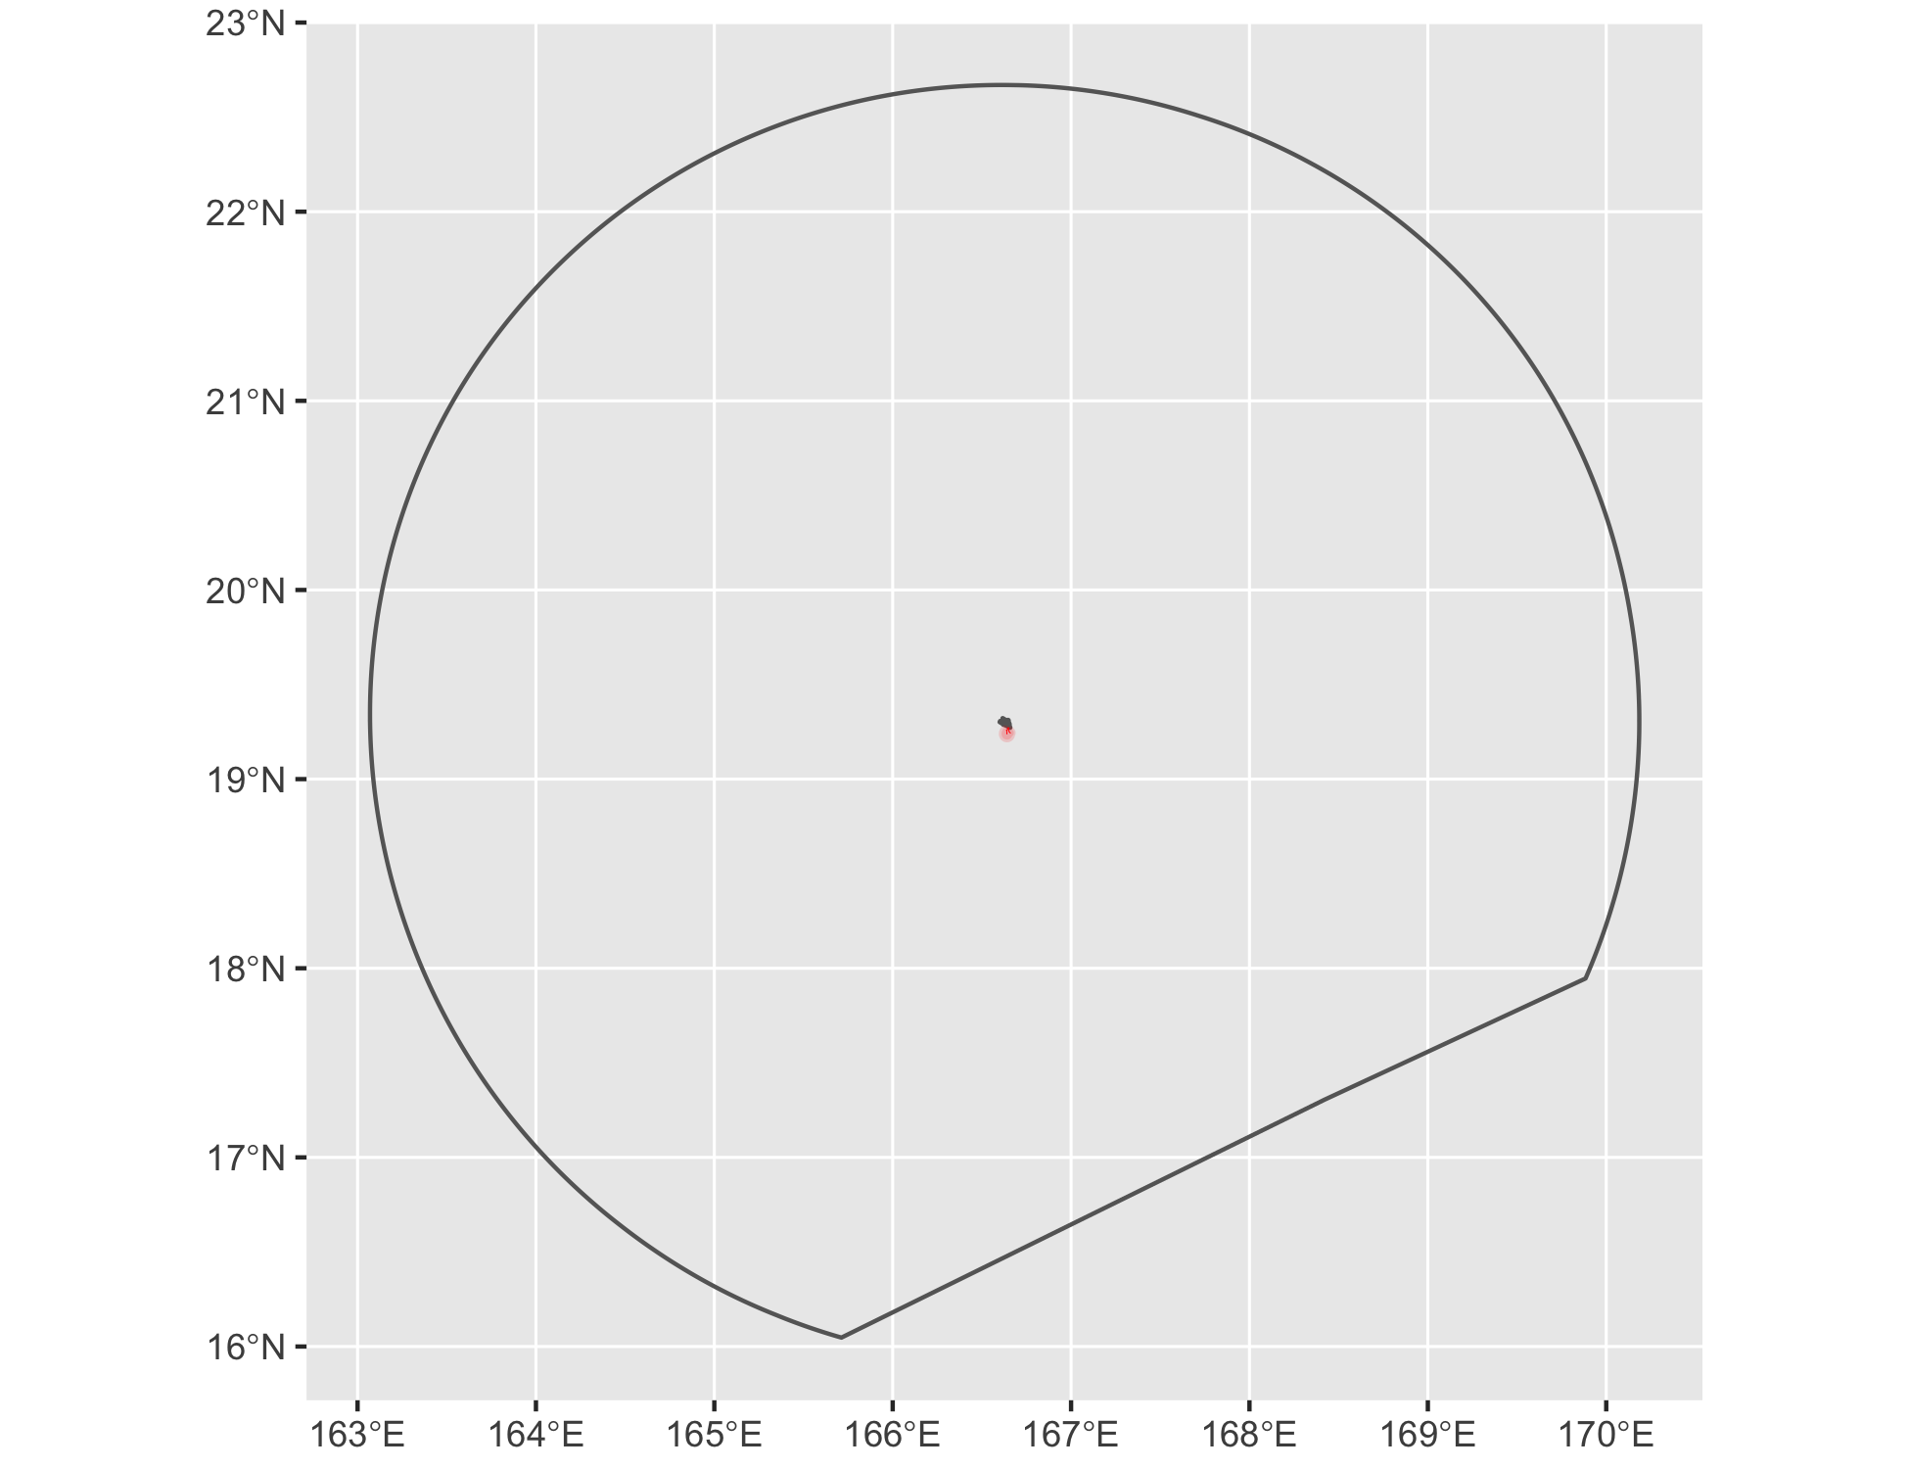

Figure 31 Cable buffers for Wake Island.

### West

See Figure 32.

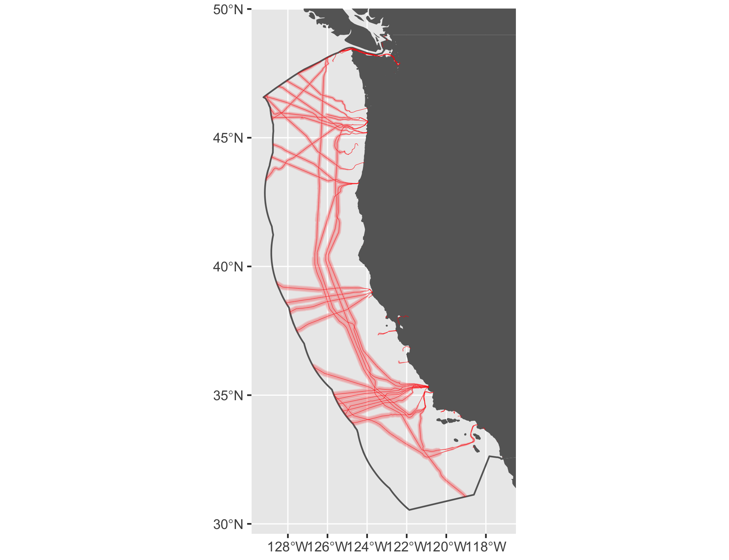

Figure 32 Cable buffers for West.

#### Tidal

See Figure 33.

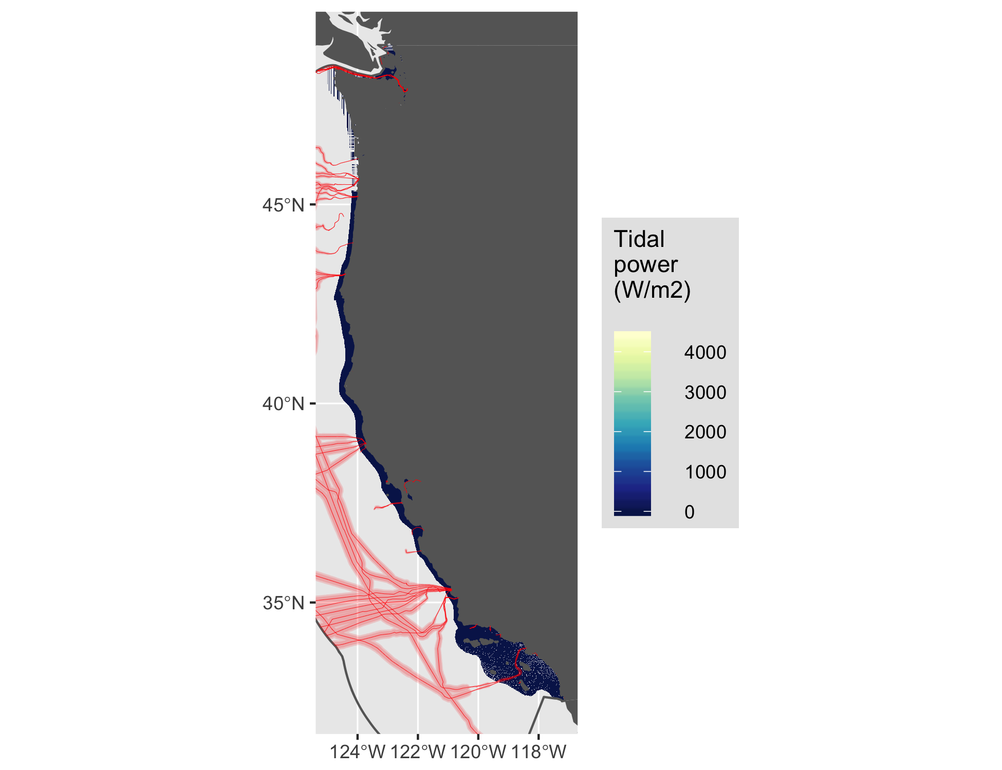

Figure 33 Tidal energy for West.

#### Wave

See Figure 34.

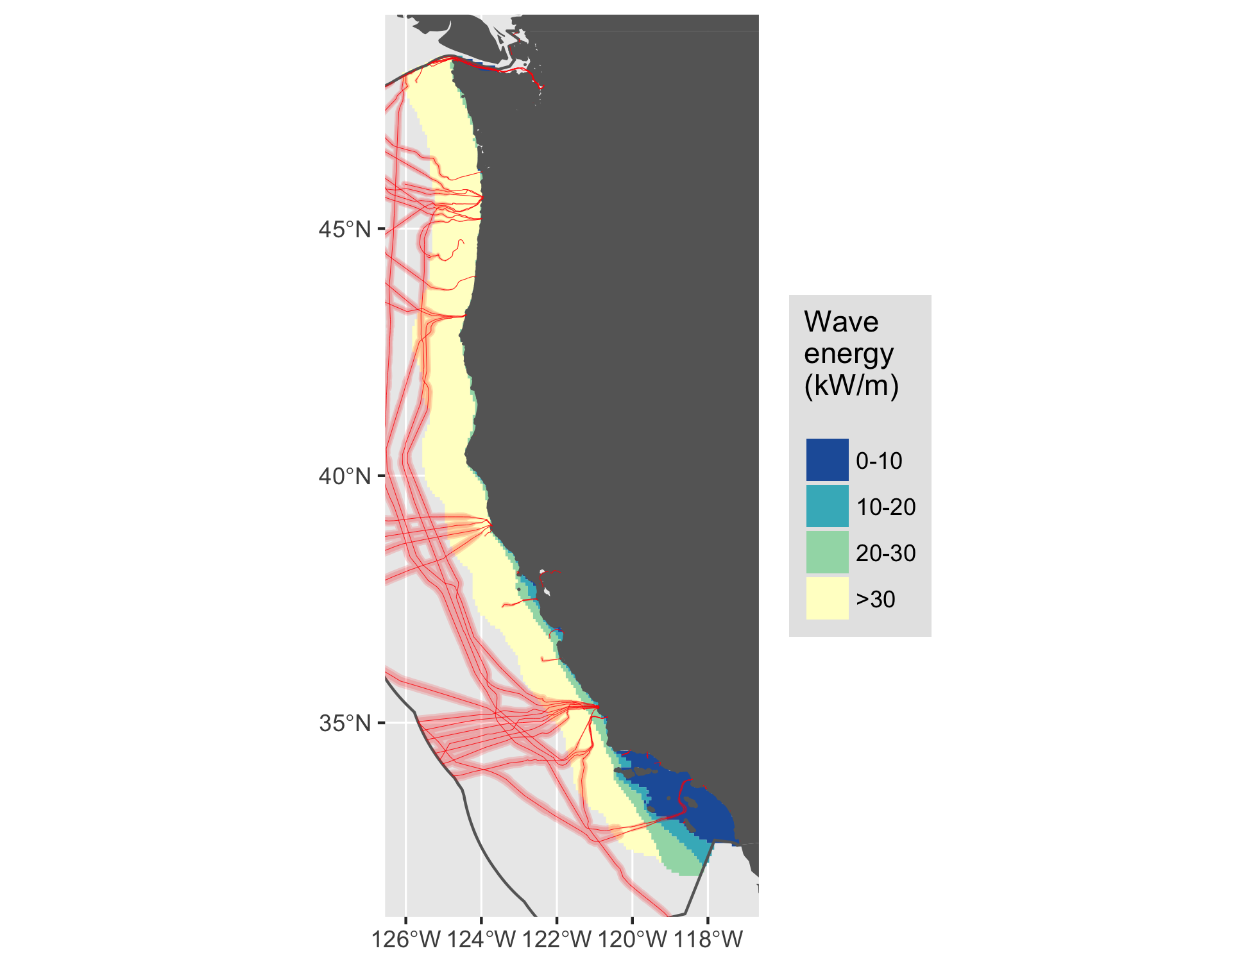

Figure 34 Wave energy for West.

#### Wind

See Figure 35.

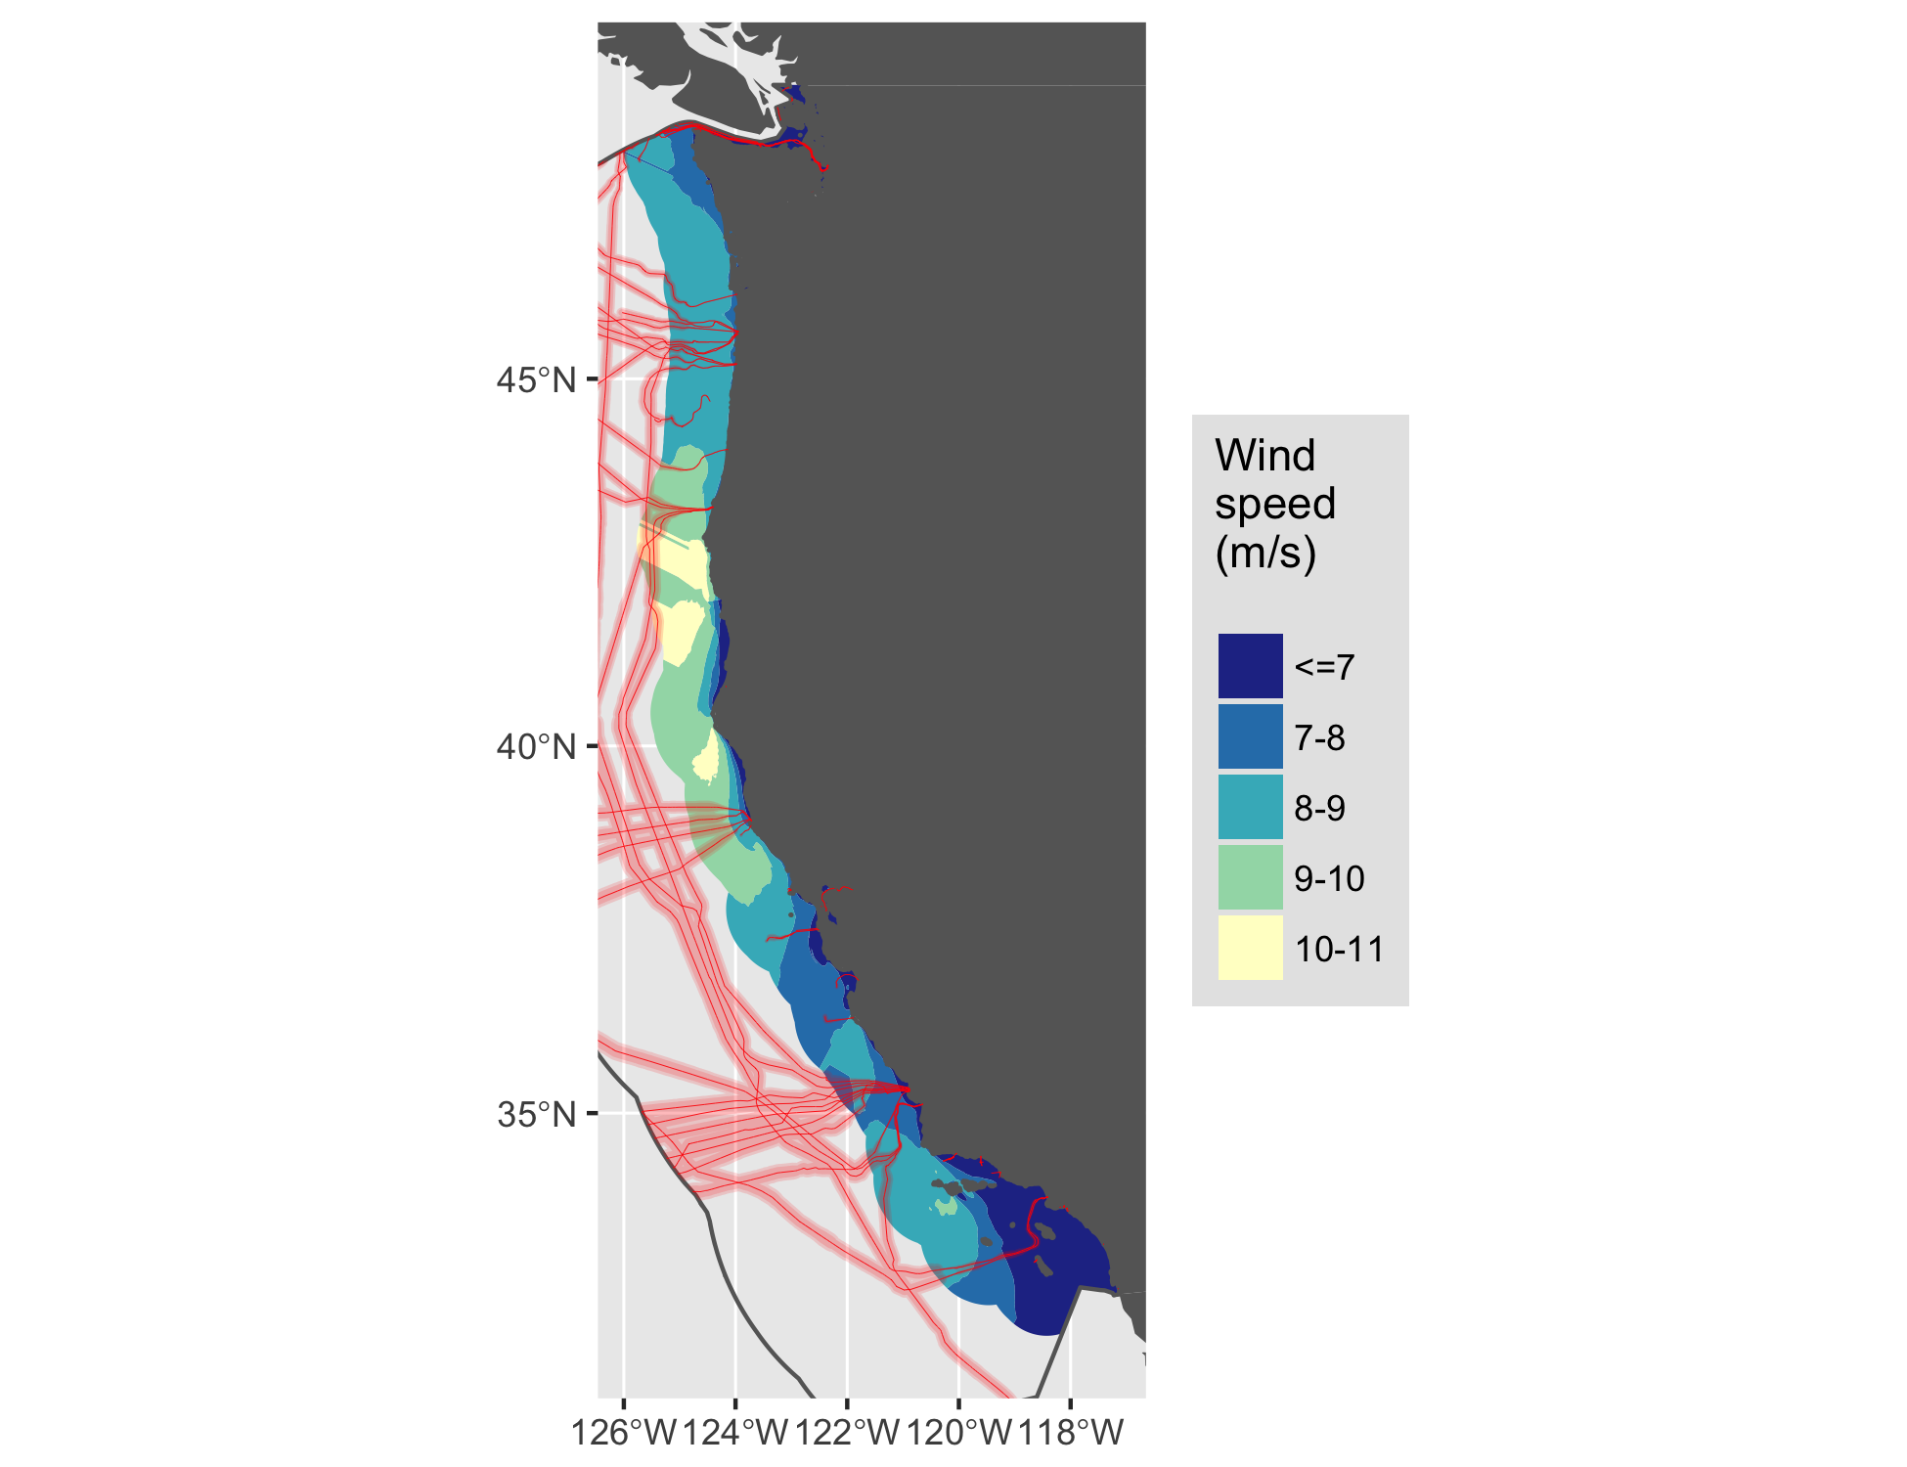

Figure 35 Wind energy for West.

# References

Amante, C., Kilcher, L., Roberts, B., & Draxl, C. (2016). *Offshore Cable Analysis: Pilot Study*.

Beiter, P., Musial, W., Kilcher, L., Maness, M., & Smith, A. (2017). *An Assessment of the Economic Potential of Offshore Wind in the United States from 2015 to 2030*. NREL (National Renewable Energy Laboratory (NREL), Golden, CO (United States)). <https://tethys.pnnl.gov/sites/default/files/publications/Beiter-et-al-2017-NETL.pdf>

Communications Security, Reliability and Interoperability Council IV. (2014). *Protection of Submarine Cables Through Spatial Separation*. <http://transition.fcc.gov/pshs/advisory/csric4/CSRIC_IV_WG8_Report1_3Dec2014.pdf>

Communications Security, Reliability and Interoperability Council IV. (2016). *Clustering of Cables and Cable Landings*.

Flanders Marine Institute. (2016). Maritime Boundaries Geodatabase: Maritime Boundaries and Exclusive Economic Zones (200NM), version 9. <http://www.marineregions.org/>. Accessed 25 April 2017

Haas, K. A., Fritz, H. M., French, S. P., Smith, B. T., & Neary, V. (2011). *Assessment of energy production potential from tidal streams in the United States*. Georgia Tech Research Corporation, Atlanta, GA (United States). <https://www.osti.gov/scitech/servlets/purl/1219367>

Jacobson, P. T., Hagerman, G., & Scott, G. (2011). *Mapping and Assessment of the United States Ocean Wave Energy Resource*. <http://www.osti.gov/scitech/servlets/purl/1060943>

Lehmann, M., Karimpour, F., Goudey, C. A., Jacobson, P. T., & Alam, M.-R. (2017). Ocean wave energy in the United States: Current status and future perspectives. *Renewable and Sustainable Energy Reviews*. <http://www.sciencedirect.com/science/article/pii/S1364032116308164>

Pachauri, R. K., Mayer, L., & Intergovernmental Panel on Climate Change (Eds.). (2015). *Climate change 2014: Synthesis report*. Geneva, Switzerland: Intergovernmental Panel on Climate Change.

Uihlein, A., & Magagna, D. (2016). Wave and tidal current energy review of the current state of research beyond technology. *Renewable and Sustainable Energy Reviews*, *58*, 1070–1081. <http://www.sciencedirect.com/science/article/pii/S1364032115016676>

VLIZ. (2017). IHO Sea Areas, version 2. VLIZ. <http://www.marineregions.org/>. Accessed 2 July 2017

1. North American Submarine Cable Association (NASCA): <https://www.n-a-s-c-a.org>
2. MarineCadastre.gov cable metadata: <https://coast.noaa.gov/dataservices/Metadata/TransformMetadata?u=https://coast.noaa.gov/data/Documents/Metadata/harvest/MarineCadastre/NOAAChartedSubmarineCables.xml&f=html>
3. GEBCO_2014 Grid, version 20150318, www.gebco.net
4. NREL Wind Prospector: <https://maps.nrel.gov/wind-prospector/>
5. NREL MHK Atlas: <https://maps.nrel.gov/mhk-atlas>
6. Wind data for 90-meter offshore: <http://www.nrel.gov/gis/data_wind.html>
7. The "one-sixth rule" for Albers Equal Area Conic projection: <http://desktop.arcgis.com/en/arcmap/latest/map/projections/albers-equal-area-conic.htm#GUID-2158C4F9-F197-458E-94F0-84933C1BE6B7>